**The Requirements Documentation of WiseInvest—Your Convenient Fund Trading Assistant**

Content

**The Requirements Documentation of WiseInvest—Your Convenient Fund Trading Assistant** 1

1. Introduction 2

1.1 Background 2

1.2 Project Scope 3

1.2.1 What Will Be Included in the Scope of This Project: 3

1.2.2 What Will Be Considered Outside the Scope of This Project: 4

1.3. References 5

1.4. Assumptions and Constraints 5

1.5. User Characteristics 5

1.5.1 Clients 5

1.5.2 System Administrators 6

2. Overall description 6

2.1 Project Features 6

2.2 Project Highlights 6

2.3 Operating Environment 7

3. System and Other Interfaces 8

3.1 Upstream system interfaces 8

3.2 Downstream system interfaces 8

3.3 Peer-level system interfaces 8

4. Description of Major Functional Requirements 10

4.1 Overall Use Case Diagram 10

4.2 Product Management Subsystem 11

4.2.1. View Product Information Use Case Specification 11

4.2.2. Product Information Editing Use Case Specification 12

4.3 Fund Account Management Subsystem 14

4.3.1 Customer Information Management Use Case Specification 14

4.3.2 Fund Account Virtual Top-up Use Case Specification 16

4.4 Subscription and Redemption Subsystem 18

4.4.1 Submit Subscription Request Use Case Specification 18

4.4.2 Submit Redemption Request Use Case Specification 20

4.5 Settlement Subsystem 21

4.5.1 Daily Initialization and Market Data Reception Use Case Specification 21

4.5.2 Transaction Management Use Case Specification 23

4.5.3 Export Data Use Case Specification 25

4.6 Business Inquiry Subsystem 27

4.6.1 View Transaction Records Use Case Specification 27

4.6.2 Use Case Specification for Requesting Cancellation 29

4.6.3 Use Case Specification for Viewing Fund Inflows and Outflows 30

4.7 Login Subsystem 32

4.7.1 Use Case Specification for Account and Password Login 33

4.7.2 Use Case Specification for Password Recovery 34

4.8 Intelligent Service Subsystem 35

4.8.1 Get Personalized Recommendations Use Case Specification 35

4.8.2 Consult AI Customer Support Use Case Specification 36

5.Functional Requirements 37

5.1. System Framework Diagram 37

5.2. System Overall Process 37

5.3. Requirements Analysis Modeling 38

5.3.1.1 Activity Diagrams 39

5.3.1.2  Swimlane Diagrams 56

5.3.2. Data Modeling 65

5.3.3.1 State Diagrams 66

5.3.3.2 Sequence Diagrams 67

6 Non-Functional Requirements 78

6.1Performance Requirements 78

6.1.1 Precision 78

6.1.2 Time Characteristics 78

6.1.3 Input/Output Requirements 79

6.2 Data Management Requirements 79

6.3 Security and Confidentiality Requirements 79

6.4 Flexibility Requirements 80

6.5 Other Specific Requirements 80

7. Operating Environment Specifications 80

7.1 Hardware 80

7.2 Supporting Software 81

7.3 Interfaces 81

7.4 Controls 81

# 1. Introduction

## 1.1 Background

The concept of WiseInvest stems from an observation of the evolving demands in the

current fund trading market, particularly the growing need among personal investors and fund companies for efficient and secure trading services. While traditional fund trading platforms in the market provide essential functionalities such as subscription, redemption, and account management, they often fall short in addressing users’ needs for more personalized and convenient experiences, such as tailored investment advice and real-time operational support. Against this backdrop, this project aims to create a comprehensive fund trading platform that not only delivers stable and reliable trading capabilities but also enhances user experience through intelligent recommendation and customer service features.

Software System Name: WiseInvest—Your Convenient Fund Trading Assistant

Developers: Student team from Tongji University's Software Engineering major, members include Yang Boxuan, Han Mingyang, Guan Yongying, Yan Wenqing

Users: Individual investors, system administrators, and fund management companies

Implementation Environment:  
System development and testing will be conducted on students' personal computers. The service registry center and database will be deployed on an Alibaba Cloud server to support internet-based access and management.

Interactions with Other Systems:

* Upstream Systems: Financial operations platforms and operation monitoring platforms require fund product information and user transaction data from this system to support their financial services and system monitoring.
* Downstream Systems: Telecommunications systems and cash management systems provide communication services and fund clearing support to this system, ensuring smooth transactions.
* Peer Systems: Data centers interact bidirectionally with this system, providing market data support and receiving transaction information.

## 1.2 Project Scope

### 1.2.1 What Will Be Included in the Scope of This Project:

**a. Development of an Intelligent Fund Trading Platform:​**

▪The project will include the design and development of a comprehensive fund trading platform that supports both individual investors and fund companies.​

▪The platform will provide core functionalities such as fund subscription, redemption, and account management.​

**b. Personalized Fund Product Recommendations:​**

▪The platform will integrate an intelligent recommendation system that offers personalized fund product suggestions based on users' risk preferences, investment goals, and historical behavior.​

▪The target accuracy rate for the recommendation system is over 85%, ensuring that users receive fund products tailored to their needs.​

**c. Fund Product Management for Fund Companies:​**

▪The platform will offer efficient fund product management functionalities for fund companies, including the launch of new funds,updates to fund information, and transaction monitoring.​

▪The platform will also provide transaction support to optimize the operational processes of fund companies.​

**d. System Stability and Security:​**

▪The platform will include robust clearing and monitoring functions to ensure system stability, with a target of 99.9% uptime.​

▪Strict security measures will be implemented to ensure the safety of user data and transaction information, with the goal of passing financial security certifications and avoiding major security vulnerabilities.​

**e. Transaction Efficiency:​**

▪The average processing time for fund transactions will be kept within 5 seconds to ensure smooth user operations.​

**f. User Experience and Satisfaction:​**

▪The platform will focus on providing a user-friendly interface and personalized experience, with the goal of achieving at least 90% user satisfaction.

### 1.2.2 What Will Be Considered Outside the Scope of This Project:

**a. Non-Fund Financial Products:​**

▪The platform will not support the trading or management of non-fund financial products such as stocks, bonds, or cryptocurrencies. The focus will remain exclusively on fund-related products.​

**b. Advanced Investment Strategies:​**

▪While the platform will provide personalized fund recommendations, it will not offer advanced investment strategies or portfolio management services such as algorithmic trading or hedge fund management.​

**c. Custom Fund Creation:​**

▪

The platform will not allow individual users to create custom funds or investment products. Fund creation and management will be limited to authorized fund companies.​

**d. Offline Transactions:​**

▪All transactions and operations will be conducted online. The platform will not support offline transactions or manual processing of fund trades.​

**e. Third-Party Financial Service Integrations:​**

▪The platform will not integrate with third-party financial services or platforms unrelated to fund trading and management.

## 1.3. References

Published Documents for This Project:

* Tongji Fund Trading System Requirements Specification

Software Development Standards:

* *Software Engineering — A Practitioner's Approach* (ISBN 978-1-260-54800-6), Roger S. Pressman, Ninth Edition

Technical Documentation:

* Spring Cloud Official Documentation, Spring.io
* Vue 3 Official Documentation, Vuejs.org
* MySQL 8.0 Reference Manual
* Nacos Configuration Center and Service Discovery Documentation, Alibaba Cloud

Business Documentation:

* *Fund Management Business Operations Guide*, China Securities Investment Fund Association, 2022
* *Fund Sales Business Management Measures*, China Securities Regulatory Commission, 2021

## 1.4. Assumptions and Constraints

The project development period is 3 months, from March 2025 to June 15, 2025.  
 The project has a budget of 5000 yuan, and the equipment includes 4 Windows OS computers and 1 Alibaba Cloud server.  
 Code collaboration and team task management will be conducted via GitHub and Feishu.

## 1.5. User Characteristics

1.5.1 Clients  
The primary client group consists of individual investors, typically with basic financial knowledge and computer operation skills. Most clients may not have professional programming or IT backgrounds.  
Clients will frequently use the system for fund subscriptions, redemptions, account information viewing, and investment income tracking.

1.5.2 System Administrators  
System administrators are usually professionals within fund companies, with educational backgrounds in finance and IT, familiar with fund management, clearing processes, and system operations.  
Administrators are responsible for daily clearing processes and will regularly use the system for clearing operations, monitoring, and troubleshooting to ensure stable system operation and accurate fund settlement.

# 2. Overall description

## 2.1 Project Features

User-Friendliness: The system will provide an intuitive and easy-to-use interface, ensuring seamless operations for customers and administrators in fund trading, account management, clearing services, and more.

Financial Transaction Processing: The system will support efficient end-to-end fund trading processes, including subscription, redemption, and cancellation, ensuring timeliness and accuracy.

Investment Risk Management: The system will incorporate risk assessment functionality to help users understand their investment risk profiles and recommend suitable fund products based on risk levels.

Data Security: The system will implement stringent data security measures to protect users' personal information and transaction data from leakage or tampering.

## 2.2 Project Highlights

**Personalized Services**

The system will evaluate customers' investment risk profiles based on their transaction history and financial status, guiding them to select risk-appropriate products.

**End-to-End Business Processes**

For customers, the system will support a complete workflow from account opening, risk assessment, fund subscription, redemption, to transaction record queries. All fund-related operations can be completed on a single platform, simplifying the investment process and enhancing user experience.

For administrators, the system will provide comprehensive transaction monitoring and daily clearing workflows. Administrators can track trading activities in real-time to ensure compliance and security. The clearing platform will automate transaction data processing, generate clearing reports, and update system status, ensuring accuracy and transparency in product trading and fund flows.

**Multi-Layered Security**

The system will adopt multi-layered security measures, including data encryption, identity authentication, and access control, to safeguard user information and transaction data.

## 2.3 Operating Environment

**Hardware Requirements**

Iteration 1: The system will run on standard computers with basic network connectivity.

Iteration 2: The system will require devices (e.g., desktops, laptops) with basic network connectivity, at least 2GB RAM, and 500MB of available storage.

**Software Compatibility**

Iteration 1: The system will support mainstream operating systems and browsers for seamless cross-platform usability.

Iteration 2: The system will be compatible with:

OS: Windows 10+, macOS 10.15+, Linux Kernel 4.0+, iOS 13+, Android 9+.

Browsers: Chrome 88+, Firefox 85+, Safari 14+, Edge 88+.

**Network Requirements**

Iteration 1: Stable internet connectivity is required to ensure timely and reliable transactions and updates.

Iteration 2: A stable connection is mandatory, with broadband or 4G/5G networks recommended (minimum 2Mbps bandwidth, latency ≤200ms).

# 3. System and Other Interfaces

## 3.1 Upstream system interfaces

**Wealth management operations platform.** The wealth management operations platform interacts with this fund trading system for data exchange. This platform needs to access the fund product information, user transaction records, and risk assessment results of this system to provide users with comprehensive wealth management services.

**Operations monitoring platform.** The operations monitoring platform will obtain the system's operational status and performance metrics through monitoring interfaces. This platform needs to monitor the system's health in real-time to ensure its stability and reliability.

## 3.2 Downstream system interfaces

Iteration 1:

**Cash management system.** This fund trading system relies on the cash management system for bank card binding, fund clearing, and settlement. The system will interface with the cash management system for fund flow to ensure the safety and accuracy of transaction funds.

Iteration 2: (added)

**Telecom system.** This fund trading system relies on the communication services provided by the telecom system to ensure the normal implementation of functions such as account opening and login. The system will send notifications via the telecom system's SMS interface.

## 3.3 Peer-level system interfaces

Iteration 1:

**Data center.** This system exchanges data with the data center to obtain market data and upload transaction information.

Iteration 2:

**Data center.** There is a bidirectional data exchange relationship between this fund trading system and the data center. The system will periodically upload transaction data and clearing processing data to the data center while obtaining market data from the data center to support normal business decision-making.

# 4. Description of Major Functional Requirements

## 4.1 Overall Use Case Diagram

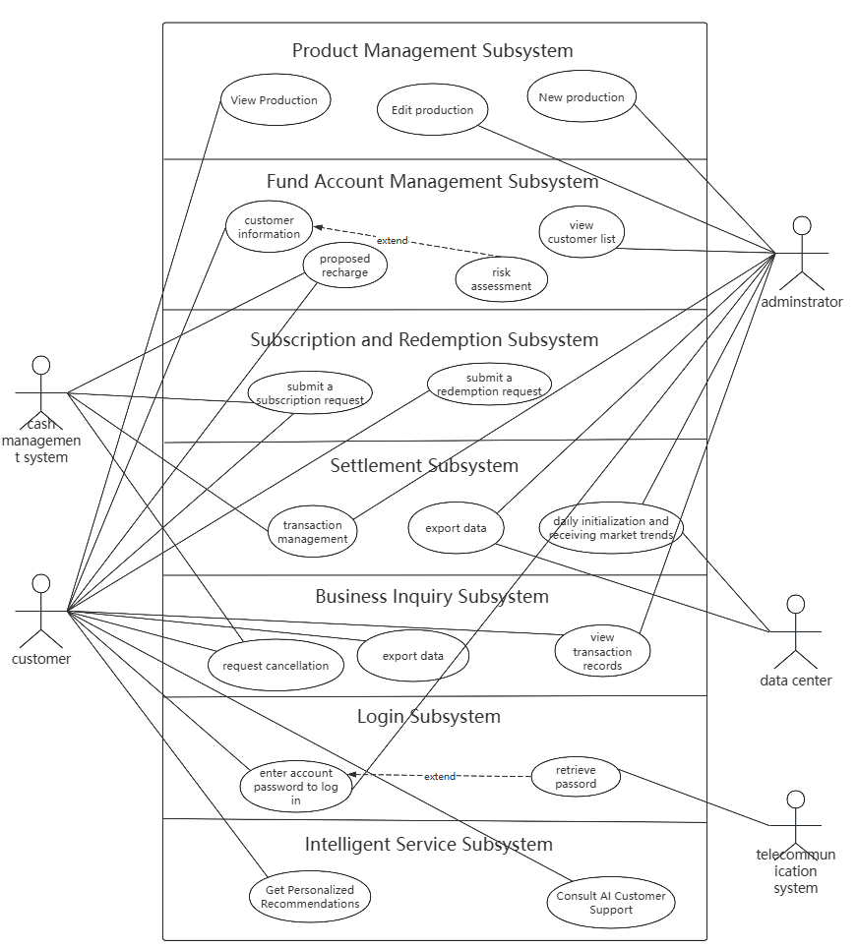

## 4.2 Product Management Subsystem

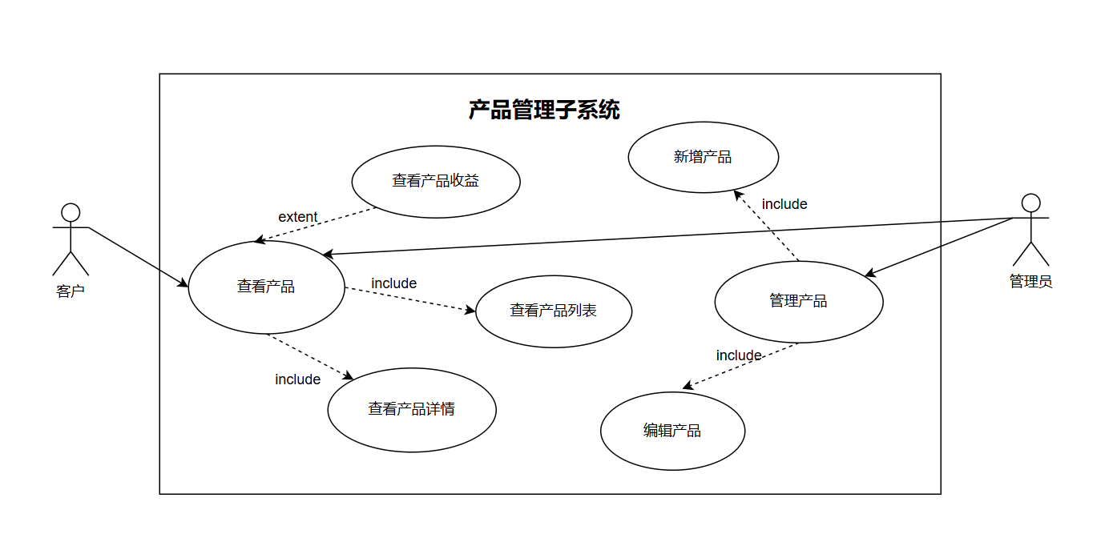

The product management subsystem allows customers and administrators to jointly participate in the lifecycle management of products. Customers can browse the product list to learn basic information about each product and its returns. For products of interest, customers can further view detailed information such as specifications and prices. As backend managers, administrators have the above permissions to view products and can also add new products, modify existing entries, and delete outdated products. This not only meets the fast-changing needs of consumers but also allows merchants to adjust inventory structures promptly to adapt to market competition.

### 4.2.1. View Product Information Use Case Specification

|  |  |
| --- | --- |
| **Name** | **View Product Information** |
| ID | UC01 |
| Summary | Customers can view basic information of all products in the system, including product lists, details, returns, etc. |
| Actors | Customer, Administrator |
| Preconditions | The customer or administrator has successfully logged into the system. |
| Postconditions | None |
| Basic Flows | 1. The customer or administrator opens the client executable file and enters the product interface. 2. The customer or administrator can filter products by category or search for specific products. 3. The system displays a list of products that meet the criteria. 4. After reading the information, the customer or administrator can choose to return to the product list or continue browsing other product details. |
| Alternative Flows | 3.a Customer views product details：   1. The customer or administrator views a specific product, and the system displays detailed information about the product.   3.b Customer views product list：  1. The customer or administrator clicks on the full list, and the system displays a list of all products.  3.c Customer views product returns：  1. If the customer has already purchased a product, they can click to view the returns of that product.  2. The system displays the returns of the product |
| Exception Flows | 2.a If the search results are empty, the system should prompt that no relevant products are found and suggest trying other keywords. |
| Business Rules | 1. Product details should include: name, product type, yesterday's returns, returns trend chart, etc. |

### 4.2.2. Product Information Editing Use Case Specification

|  |  |
| --- | --- |
| **Name** | **Edit Product Information** |
| ID | UC02 |
| Summary | Administrators can edit existing product information in the system, including modifying product names, updating product descriptions, etc. |
| Actors | Administrator |
| Preconditions | The administrator has logged into the system with administrator privileges. |
| Postconditions | The updated product information takes effect immediately, and customers can see the latest information when viewing the product. |
| Basic Flows | 1. After logging into the system, the administrator navigates to the product management page. 2. The administrator selects the product to be edited from the product list. 3. The administrator enters the editing page. 4. The administrator modifies the required information on the editing page. 5. After completing the modifications, the administrator saves the changes. 6. The system verifies whether the input information meets format requirements. If it does, the changes are saved, and the system returns to the product list page, displaying the updated information. |
| Alternative Flows | 3.a Administrator adds a new product:   1. The administrator can add a new product and save it.   4.a Administrator deletes outdated products:  1. The administrator can choose to delete a product on the editing page and save the changes. |
| Exception Flows | 4.a If the administrator attempts to edit a product marked as deleted, the system should prompt that the product has been deleted and cannot be edited.  4.bIf the network is interrupted or the server encounters issues during editing, the system should handle the exception properly to prevent data loss  6.a If the input does not meet format requirements, the system displays an error message, guiding the administrator to correct the error. The administrator corrects the error and attempts to save again. |

## 4.3 Fund Account Management Subsystem

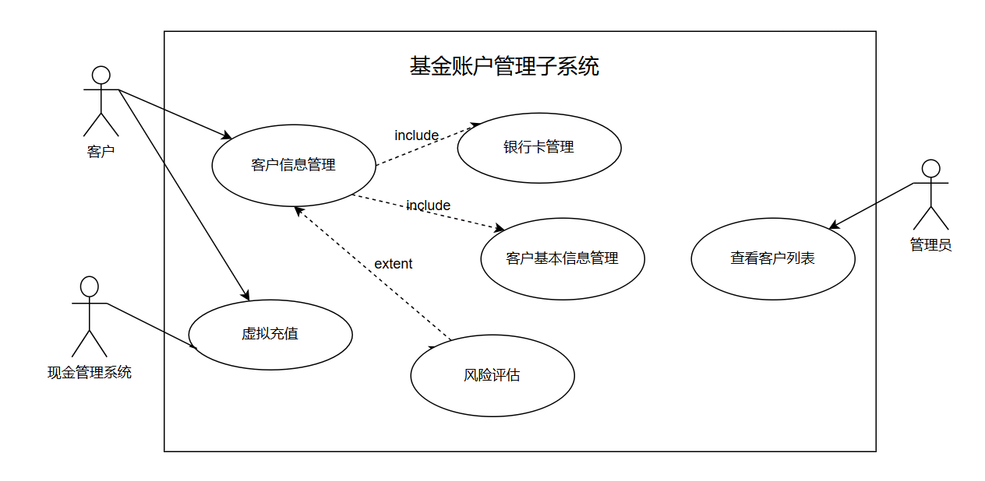

The fund account management subsystem is a comprehensive financial management platform designed to help customers efficiently manage their fund accounts. Customers can view and manage their personal information, including basic details such as name, contact information, and address, through the customer information management module. Under the bank card management module, customers can bind and associate multiple bank cards for future fund transfers. The system also periodically reminds customers to monitor the status of their bank cards to avoid issues caused by untimely processing. Administrators have access to the customer list function to monitor all customer activities, ensuring each customer receives appropriate service and support. The virtual top-up module simulates a currency top-up process to test system performance and collect feedback. Customers can perform risk assessments on their accounts in the personal information interface.

### 4.3.1 Customer Information Management Use Case Specification

|  |  |
| --- | --- |
| **Name** | **Customer Information Management** |
| ID | UC03 |
| Summary | Customers can view and edit their personal information, including basic details such as name, contact information, and address. |
| Actors | Customer |
| Preconditions | 1. The customer has logged into the system. |
| Postconditions | 1. he customer's personal information is updated successfully, and the system logs the changes |
| Basic Flows | 1. After logging into the system, the customer navigates to the personal center page. 2. The customer enters the personal information viewing page. 3. The system displays the customer's information and bank card details. 4. The customer enters the personal information editing page 5. The customer modifies the required information on the editing page. 6. After completing the modifications, the customer chooses to save. 7. The system verifies whether the input information meets format requirements. If it does, the changes are saved, and the system returns to the personal information viewing page, displaying the updated information. |
| Alternative Flows | 3.a Customer manages basic personal information:  1 The customer locates their basic information and views it.  3.bCustomer manages bank cards:   1. The customer finds the bank card option in the detailed information section and views their bank cards and accounts.   3.c If the customer frequently adds bank cards, the system generates a risk alert and notifies the customer.  3.d Customer performs a risk assessment on their account:  1. The customer can choose to perform a risk assessment on their account. |
| Exception Flows | 3.a If the customer unbinds a bank card while there are unredeemed transactions, the unbinding fails, and the system notifies the customer.  4.a. If the customer does not perform any operations for an extended period during editing, the system may automatically exit editing mode to prevent data loss.  5.a . If the customer inputs information that does not meet format requirements (e.g., incorrect phone number format), the system displays an error message.  6.a If the system encounters network interruptions or server issues during saving, it should handle the exception properly to prevent data loss and prompt the customer to retry.  7.a  1. if the input does not meet format requirements, the system displays an error message, guiding the customer to correct the error.  2. The customer corrects the error based on the prompt and attempts to save again. |
| Business Rules | 1. Risk assessment: The customer fills out a form to perform a risk assessment on their account during account opening. In the personal information interface, the customer can also choose to perform a risk assessment, filling out a form including options such as occupation and disposable income. The system generates a risk assessment report based on the form content.  2. Relationship between customers and bank cards: One fund account can be bound to multiple bank cards, but one bank card can only be bound to one fund account.  3. Bank card rebinding: After rebinding a bank card, the customer cannot rebind again within one week. If such an operation is attempted, the system will notify the customer. |

### 4.3.2 Fund Account Virtual Top-up Use Case Specification

|  |  |
| --- | --- |
| **Name** | **Virtual Top-up** |
| ID | UC04 |
| Summary | Customers can top up funds into their fund accounts for subsequent purchases of fund products |
| Actors | Customer, Cash Management System |
| Preconditions | 1. The customer has logged into the system and bound at least one bank card. |
| Postconditions | After a successful top-up, the customer's account balance is updated in real-time. |
| Basic  Flow | 1. After logging into the system, the customer navigates to the personal center page. 2. The customer selects the top-up option under the fund management section. 3. The customer selects the top-up method (e.g., bank card top-up) and enters the top-up amount. 4. The customer confirms the top-up information is correct. 5. The system guides the customer through the payment process, which may include redirecting to a third-party payment platform. 6. After a successful top-up, the system updates the customer's account balance and displays a success message on the page. 7. The cash management system receives the topped-up assets. 8. The customer can view the latest account information on the account balance page. |
| Alternative Flows | None |
| Exception Flows | 4.a . If the customer enters a top-up amount that exceeds the bank card limit, the system should prompt that the top-up amount exceeds the limit and suggest choosing another payment method or reducing the amount.  5.a If issues occur during payment, the system should provide an error message and suggest the customer check the network connection or contact customer service.  5.b For high-risk operations (e.g., large top-ups), the system may initiate additional security verification measures, such as SMS verification codes. |
| Business Rules | 1. The system should set a reasonable range for top-up amounts, such as below 1 million, to prevent illegal operations. |

## 4.4 Subscription and Redemption Subsystem

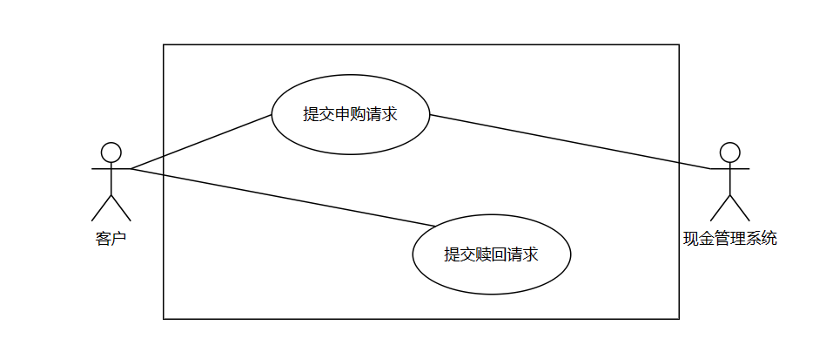

The subscription and redemption subsystem should fulfill the following functional requirements:

Support customers in selecting products, entering subscription amounts, and submitting subscription requests. The system checks customer risk levels, account balances, records subscription-related information, and displays a success message.

Support customers in selecting products, entering redemption shares, and submitting redemption requests. The system ensures the redemption shares are valid, records the relevant information, and displays a success message.

### 4.4.1 Submit Subscription Request Use Case Specification

|  |  |
| --- | --- |
| **Name** | **Submit Subscription Request** |
| ID | UC05 |
| Actors | Customer, Cash Management System |
| Preconditions | 1. 1. The customer has successfully logged into the system. 2. The customer has selected a financial product and entered the subscription page. |
| Postconditions | 1. 1. The system successfully records the subscription information, including product ID, customer account, purchase amount, etc. 2. The cash management system deducts the user's balance. |
| Basic Flow | 1. The customer selects a financial product and enters the subscription amount. 2. The customer submits the subscription information. 3. The system checks whether the customer's risk level matches the product's risk level. 4. The system verifies whether the purchase amount is less than or equal to the account balance. 5. After verification, the cash management system deducts the customer's account balance. 6. The system records the subscription information, including customer account, product ID, amount, time, etc. |
| Alternative Flows | 3.a Customer cancels the operation：   1. The customer selects "Cancel," and the system returns to the product details page. |
| Exception Flows | 3.a Risk level mismatch：   1. The system prompts "Risk level mismatch, subscription cannot proceed."。   3.b Insufficient account balance:   1. The system prompts "Insufficient account balance," allowing the customer to re-enter the amount or navigate to the top-up page： 2. The system prompts "Deduction failed, please try again later," and returns to the subscription page. |
| Business Rules | 1. Orders are confirmed by default on T+1 day. 2. The system records subscription information, including customer account, product ID, amount, time, etc. 3. The account balance is adjusted based on the purchase amount to determine whether further purchases are possible. 4. A unique application ID is generated and recorded based on transaction time, sequence, etc. 5. If the customer's risk tolerance does not match the product's risk level, a prompt is displayed on the order page. 6. If the subscription amount exceeds the customer's account balance, a prompt is displayed on the order page. 7. A fund flow record is added to track fund usage. |

### 4.4.2 Submit Redemption Request Use Case Specification

|  |  |
| --- | --- |
| **Name** | **Submit Redemption Request** |
| ID | UC06 |
| Actors | Customer |
| Preconditions | 1. The customer has successfully logged into the system.； 2. The customer has selected a financial product and entered the redemption page. |
| Postconditions | 1. The system successfully records the redemption information, including product ID, customer account, redemption shares, etc. |
| Basic Flow | 1. he customer selects a financial product and enters the redemption shares. 2. The customer submits the redemption information. 3. The system checks whether the redemption shares do not exceed the customer's holding shares. 4. After verification, the system deducts the corresponding product shares from the customer's account. 5. The system records the redemption information, including product ID, customer account, redemption shares, time, etc. |
| Alternative Flows | 3.a Customer cancels the operation:   1. The customer selects "Cancel," and the system returns to the product details page. |
| Exception Flows | 3.a Redemption shares exceed the limit:   1. The system prompts "Redemption shares exceed available shares," allowing the customer to re-enter the redemption shares. |
| Business Rules | 1. Redemption shares must be positive integers. 2. Redemption shares cannot exceed the customer's current holding shares of the product. 3. The system records redemption transaction details, including method, account, product code, redemption shares, fund method, etc. 4. A unique application ID is generated and recorded based on transaction time, sequence, etc. |

## 4.5 Settlement Subsystem

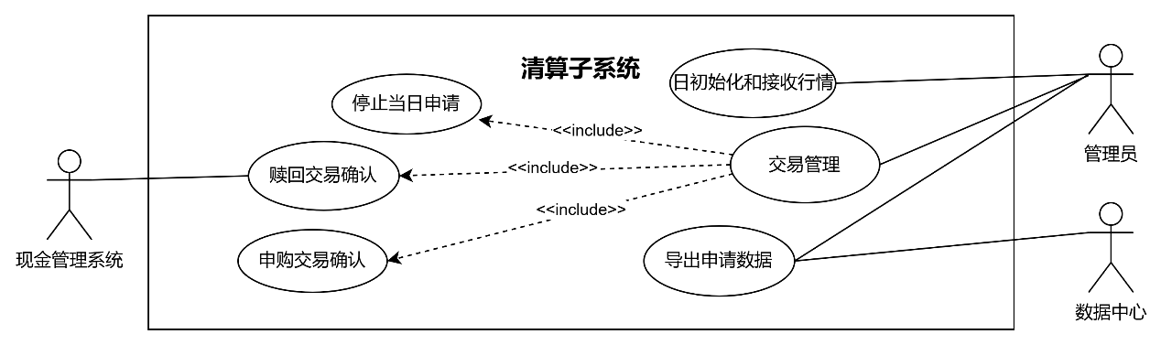

The Settlement subsystem should fulfill the following functional requirements:

At the start of a new business day, the administrator retrieves the new net value of fund products.

The administrator confirms subscription and redemption requests from the previous trading day, completing the corresponding share conversions and fund deposits.

The administrator closes the application channel for the current trading day and opens the application channel for the next trading day.

The administrator exports all transaction processing data to the data center.

### 4.5.1 Daily Initialization and Market Data Reception Use Case Specification

|  |  |
| --- | --- |
| **Name** | **Daily Initialization and Market Data Reception** |
| ID | UC07 |
| Summary | The operator enters the daily clearing process interface of the clearing subsystem and performs daily initialization. The system updates the current business day, receives market data from the previous trading day, and generates the new net value of products for the day. |
| Actors | Administrator |
| Preconditions | All applications from the previous trading day have been processed and exported to the data center. |
| Postconditions | The system updates the trading day date and retrieves the daily net value of all fund products. |
| Basic Flow | 1. The administrator enters the daily clearing process interface.； 2. The administrator performs the daily initialization operation, and the system updates the trading day date.； 3. The administrator performs the market data reception operation, and the system initiates a data request to the data center to retrieve the net value information of fund products for the day. 4. The data center returns the corresponding fund net value data； 5. The system verifies data integrity and saves the data. |
| Exception Flows | 2.a. The clearing process for the previous trading day is not completed：  1. The system prompts that daily initialization cannot begin；  2. The system jumps to the pending clearing step；  5.a. The data center does not respond to the request for fund net value data:  1. The system logs the request timeout.；  2. The system retries the request and notifies the administrator if the retry count reaches the predetermined threshold；  5.b. The data center returns incomplete or malformed data：  1. The system logs the error and triggers an alert.；  2. The administrator is notified to manually request data re-import |
| Business Rules | 1. Updates the trading date to the next valid business day (excluding weekends and public holidays such as National Day)；  2. The system simulates daily NAV fluctuations using a random multiplier (90%–110% of the previous day’s NAV)；  3. NAV updates are mandatory and independent of client transactions. All products must be updated daily, regardless of trading activity. |

### 4.5.2 Transaction Management Use Case Specification

|  |  |
| --- | --- |
| **Name** | **Transaction Management** |
| **ID** | UC08 |
| Summary | The administrator processes all subscription requests from the previous trading day in bulk. The system calculates and updates the clients' holdings.  The administrator processes all redemption requests from the previous trading day in bulk. The system calculates and updates the clients' holdings and deposits the redemption amount into their accounts.  The administrator closes the submission channel for the current trading day and opens the channel for the next trading day.。 |
| Actors | Administrator，Cash Management System |
| Preconditions | 1. The system has successfully retrieved the current day’s market data. 2. When the "Stop Current Day Submissions" sub-activity begins, there are no pending submissions in the system. |
| Postconditions | 1. The subscription or redemption amount has been successfully transferred.； 2. Subscription or redemption records are updated, including request status, shares, amount, etc.； 3. The system status is updated to "Current Day Submissions Stopped," rejecting any new submissions for the current day. All subsequent submissions will be recorded as requests for the next trading day. |
| Basic Flow | 1. The administrator enters the daily clearing process interface.； 2. The administrator performs transaction management operations, including:   Confirming subscription transactions  Confirming redemption transactions  Stopping current-day submissions   1. The transaction confirmation process for the current day’s clearing is completed. |
| Alternative Flows | 2.a. Subscription Confirmation Sub-Activity Flow:  1.The administrator confirms subscription transactions, and the system processes all valid subscription requests for the day.  2.The system updates the user’s holdings, increasing their fund shares based on the subscription amount.  3.The clearing log records each confirmed subscription transaction, including subscription amount, confirmed shares, transaction date, confirmation time, etc.  2.b. Redemption Confirmation Sub-Activity Flow:  1.The administrator confirms redemption transactions, and the system processes all valid redemption requests for the day.  2.The system updates the user’s holdings, deducting the redeemed fund shares.  3.The system sends a request to the Cash Management System to deposit the redemption amount into the user’s account.  4.The system records each confirmed redemption transaction, including redeemed shares, confirmed amount, transaction date, confirmation date, order status, etc.  5.The system records the bank transaction details for each redemption, including creation time, bank card number, transaction amount, business type, etc.  2.c. Stop Current Day Submissions Sub-Activity Flow:  1.The administrator executes the "Stop Current Day Submissions" operation.  2.The system prompts the administrator to confirm and displays statistics of the current day’s submissions (number of subscription and redemption requests).  3.Upon confirmation, the system updates its status to "Current Day Submissions Stopped," notifies the subscription/redemption subsystem, stops accepting new submissions for the current day, and opens the submission channel for the next trading day. |
| Exception Flow | 2.a. Failure to Retrieve Previous Day’s Subscription/Redemption Requests:  1.The system logs the failure, including the IDs of the failed requests.  2.The system sends an alert to the administrator.  3.The administrator retries the data retrieval.  4.If retries fail, the administrator manually inputs the missing data.  2.b. Pending Submissions Prevent Channel Closure:  1.The system displays the status of pending submissions and prompts the administrator to retry later.  2.The administrator waits for completion and retries. |
| Business Rules | 1. Subscription shares and redemption amounts are calculated based on the fund’s net asset value (NAV) for the day.； 2. Subscription shares = Subscription amount / NAV； 3. Redemption amount = Redeemed shares × NAV； 4. After stopping submissions for the current day, the system closes the current day’s channel and opens the next day’s channel. All subsequent submissions are processed as requests for the next trading day. 5. Before the clearing subsystem exports data to the data center, users may still cancel their pending transactions. 6. All valid (non-canceled) transactions submitted between the opening and closing of the trading day’s submission channel (T day) are processed in the T+1 clearing cycle. |

### 4.5.3 Export Data Use Case Specification

|  |  |
| --- | --- |
| **Name** | **Export Data** |
| ID | UC09 |
| summary | The system exports transaction confirmation and request data from the daily clearing process and submits it to the Data Center. |
| Actors | Administrator,Data Center |
| Preconditions | 1. All valid subscription and redemption requests from T-1 have been confirmed. 2. The current trading day (T day) has ended, and the submission channel for T day is closed. |
| Postconditions | The system successfully sends all request data to the Data Center.  Transmission logs are recorded. |
| Basic Flow | 1. The administrator enters the clearing schedule interface. 2. The administrator executes the "Export Request Data" operation.； 3. The system extracts the data to be exported, including:   Confirmed subscription and redemption requests from T-1.  Valid (non-canceled) subscription and redemption requests submitted during T day’s submission channel.；   1. The data is sent to the Data Center in batches, with progress displayed.； 2. The Data Center returns a confirmation receipt. 3. The system logs a successful transmission. |
| **Exception Flow** | 3.a. Data Rollback:：   1. Rollback is triggered if:   The Data Center does not return a confirmation or returns a failure. Partial batch export fails. The export process is interrupted or times out   1. . The system checks data marked as "Exporting" or "Partially Successful" and reverts them to "Pending Export," deleting temporary files.； 2. The system logs the rollback and notifies the administrator.； 3. The administrator manually retries the export.； 4. If rollback fails, a detailed error report is generated for manual intervention. |
| Business Rules | 1. Data sent to the Data Center on T day includes:： 2. Confirmed T-1 subscription requests (subscription amount, confirmed shares, etc.). 3. Confirmed T-1 redemption requests (redeemed shares, confirmed amount, etc.).； 4. Valid (non-canceled) T day subscription requests (subscription amount, status: pending confirmation).； 5. Valid (non-canceled) T day redemption requests (redeemed shares, status: pending confirmation).； 6. Once data is successfully exported to the Data Center, cancellations are no longer supported. |

## 4.6 Business Inquiry Subsystem

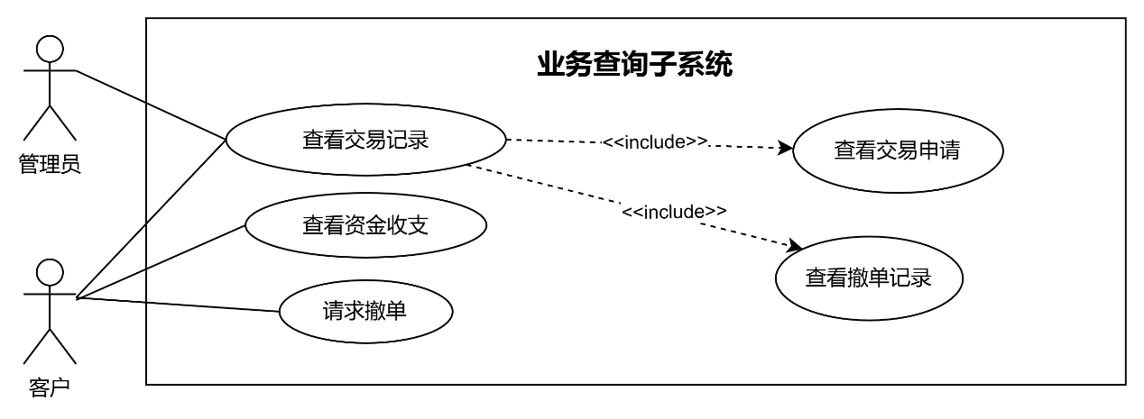

In the business inquiry subsystem, the following functional requirements should primarily be fulfilled:

Administrators or customers can view the application records for fund subscriptions, redemptions, and cancellations.

Customers can request to cancel subscription or redemption applications submitted on the previous trading day.

Customers can view the fund inflows and outflows of the products they have purchased.

### 4.6.1 View Transaction Records Use Case Specification

|  |  |
| --- | --- |
| **Name** | **View Transaction Records** |
| ID | UC10 |
| summary | Customers view their submitted subscription, redemption, and cancellation records; administrators view all transaction records. |
| actor | Customer, Administrator |
| Preconditions | Transaction application data has been imported into the system, and the status is clear. |
| Postconditions | None |
| Basic Flow: | 1. The customer or administrator enters the transaction inquiry interface. 2. The customer or administrator inputs the query conditions. 3. The customer or administrator executes the query for transaction applications or cancellation records. 4. The system queries transaction records based on the conditions and displays matching results. 5. The customer or administrator views the query results. |
| Alternative Flows: | 2.a. The querying role is a customer:  The customer inputs query conditions, such as transaction account number, application date range, product name or code, transaction type (subscription/redemption), transaction status (pending/completed), etc.  2.b. The querying role is an administrator:  The administrator inputs query conditions, such as customer ID number, fund account number, transaction account number, application date range, product name or code, transaction type (subscription/redemption), transaction status (pending/completed), etc. |
| Exception Flows | 2.a. Incomplete or incorrectly formatted query conditions:  1.The system displays an error message.  2.The customer or administrator re-enters the query conditions and resubmits the query.  3.a. No matching transaction records found:  1.The system prompts that no eligible transaction records exist.  2.The customer or administrator modifies the query conditions and re-queries.  3.b. Data access exception:  1.The system identifies the cause of the exception, such as database connection failure or timeout.  2.The system responds with a query failure and prompts the user to try again later.  3.The system administrator checks and repairs the system fault  4.The customer waits briefly and retries the query. |

### 4.6.2 Use Case Specification for Requesting Cancellation

|  |  |
| --- | --- |
| **Name** | **Request Cancellation** |
| ID | UC11 |
| summary | A customer requests to cancel an unconfirmed subscription or redemption transaction. |
| actor | Customer, Cash Management System |
| Preconditions | The system has successfully queried the customer’s subscription or redemption application. |
| Postconditions | The order status is updated from "Pending Confirmation" to "Cancelled." |
| Basic Flow | 1. The customer enters the transaction inquiry interface and queries the corresponding subscription or redemption transaction records.； 2. The system determines whether the matched transaction records support cancellation and provides a cancellation option for eligible orders.； 3. The customer selects the order to cancel and executes the cancellation operation.； 4. The system performs the cancellation and updates the order status from "Pending Confirmation" to "Cancelled." |
| Alternative Flows | 4.a. If the order type is a subscription:  1.The system sends a refund request for the subscription amount to the cash management system.  2.The cash management system refunds the subscription amount to the corresponding bank card and returns a successful refund response.  3.The system receives the successful refund response, confirming the refund for the subscription order. |
| Exception Flows: | 4.a. The selected transaction record has already been sent to the data center, exceeding the cancellation time limit:  1.The system prompts a timeout.  2.The customer abandons the cancellation operation.  4.b. The system fails to cancel due to data processing exceptions or connection timeouts:  1.The system prompts a cancellation exception.  2.The customer may retry the operation later. |
| Business Rules: | 1.From the opening of the T-day trading channel until the export of transaction data to the data center after the channel closes, all successfully submitted transaction applications support cancellation.  2.All transaction orders successfully exported to the data center on T-day cannot be cancelled and will proceed to the T+1 settlement confirmation process. |

### 4.6.3 Use Case Specification for Viewing Fund Inflows and Outflows

|  |  |
| --- | --- |
| **Name** | **View Fund Inflows and Outflows** |
| ID | UC12 |
| summary | Customers view the earnings of products under their fund accounts and query fund transaction records within the account. |
| actor | Customer |
| Preconditions: | The customer’s transaction account has at least one fund transaction record. |
| Postconditions | None |
| Basic Flow: | 1. The customer logs into the system and navigates to the fund inflows and outflows inquiry interface.； 2. The customer selects to query the earnings of fund products or the transaction records of the account.； 3. The user views, exports, or further analyzes the query results. |
| Alternative Flows: | 2.a. Customer views the earnings of products under the fund account:  1.The customer selects a fund account or specific product and may specify a time range.  2.The system retrieves fund earnings records matching the conditions.  3.The system displays earnings information, including fund name, earnings time, earnings amount, and cumulative earnings.  2.b. Customer queries fund transaction records:  1.The customer selects a transaction account under the fund account.  2.The customer inputs query conditions, such as time range and transaction type.  3.The system retrieves eligible fund transaction records.  4.The system displays transaction details, including transaction time, transaction type, amount, and transaction reason. |
| Exception Flows: | 2.a. Incomplete or incorrectly formatted query conditions:  1.The system displays an error message.  2.The customer or administrator re-enters the query conditions and resubmits the query.  2.a. No matching fund transaction records found:  1.The system prompts that no eligible transaction records exist.  2.The customer modifies the query conditions and re-queries.  3.b. Data access exception:  1.The system identifies the cause of the exception, such as database connection failure or timeout.  2.The system responds with a query failure and prompts the user to try again later.  3.The system administrator checks and repairs the system fault.  4.The customer waits briefly and retries the query. |
| Business Rules: | Fund inflows and outflows involve transaction types such as bank card top-ups, subscription amount expenditures, redemption confirmations, subscription cancellation refunds, etc. |

## 4.7 Login Subsystem

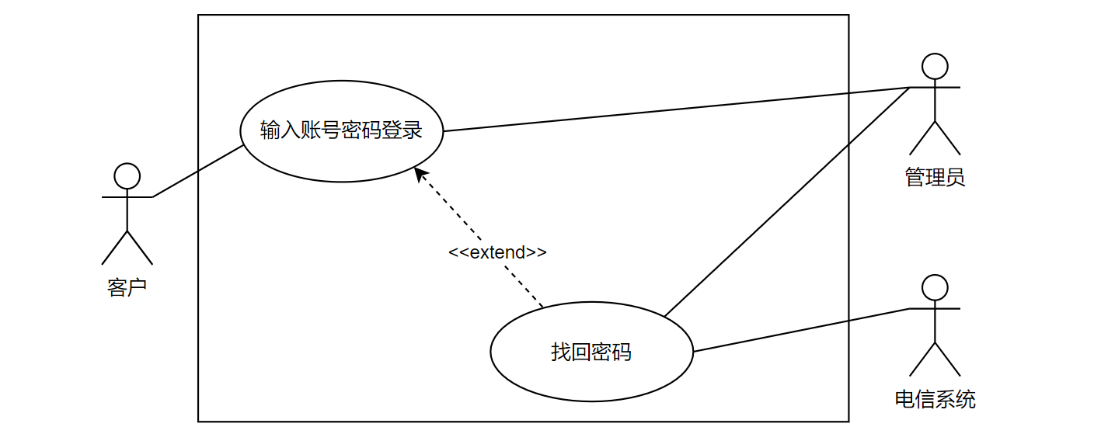

In the login subsystem, the following functional requirements should be fulfilled:

Customers or administrators authenticate by entering their account and password. After successful verification, the system grants corresponding access permissions based on their roles.

Users can set a new password to restore account access after identity verification via the telecom system.

### 4.7.1 Use Case Specification for Account and Password Login

|  |  |
| --- | --- |
| **Name:** | **Account and Password Login** |
| ID | UC13 |
| actor | Customer or Administrator |
| Preconditions: | 1. The user has entered the login page.； 2. The user has a valid account and password.； |
| Postconditions: | 1. If verification succeeds, the user enters the system’s functional homepage.； 2. If verification fails, the system displays an error message and allows retries.； |
| Basic Flow: | 1. The user enters their mobile number and account password on the login page and logs in. 2. The system verifies whether the mobile number and password are correct. 3. Upon successful verification, the system generates a login session for the user and enters the system homepage. |
| Alternative Flows: | 2.a The user selects "Forgot Password":：   1. The system redirects to the password recovery page. |
| Exception Flows: | 3.a No account matches the mobile number:：   1. The system prompts, "No account matches the mobile number," and allows re-entry.   3.b Incorrect password:：   1. The system prompts, "Incorrect password," and allows re-entry.。   3.c System busy:：   1. The system prompts, "System busy. Please try again later."。 |
| Business Rules: | 1. The user enters the login page, inputs their mobile number and account password, and logs in.。 2. If the mobile number has no matching account or the password is incorrect, the system provides corresponding prompts. 3. If the user forgets their password, they can select the "Forgot Password" option. |

### 4.7.2 Use Case Specification for Password Recovery

|  |  |
| --- | --- |
| **Name:** | **Recover Password** |
| Id | UC14 |
| actor | Customer or Administrator |
| Preconditions: | 1. The user has entered the password recovery page. |
| Postconditions | 1. The new password set by the user after identity verification takes effect.； |
| Basic Flow: | 1. The user enters the password recovery page from the login page. 2. The user inputs the mobile number linked to the account for verification. 3. The telecom system sends a verification code to the user’s mobile number.。 4. The user inputs the verification code and submits it. 5. After verification succeeds, the user sets and confirms a new password. 6. The system saves the new password. |
| Alternative Flows: | 4.a The user does not receive the verification code:  The system allows resending the verification code. |
| Exception Flows: | 3.a No account matches the mobile number:：   1. The system prompts, "No account matches the mobile number," and allows re-entry.   5.a The two new password entries do not match：   1. The system prompts, "Passwords do not match," and requires re-entering both passwords. |
| Business Rules: | 1. After entering the password recovery page, the user inputs their mobile number. The system checks whether a matching account exists. If not, it prompts accordingly. 2. The telecom system verifies whether the user is operating in person based on the mobile number. If verified, the user can input a new password. 3. If the user inputs two consistent new passwords, the password is updated. If the two entries are inconsistent, the system prompts accordingly. |

## 4.8 Intelligent Service Subsystem

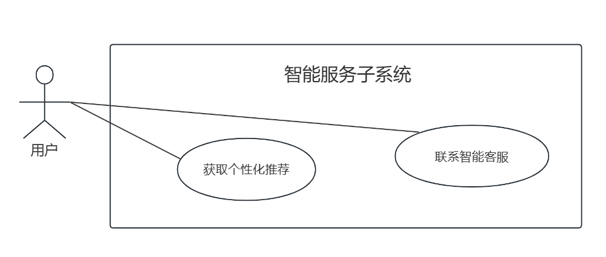

The Intelligent Service Subsystem empowers customers with AI-driven personalized fund recommendations based on their risk profiles and investment history, while providing instant support through a smart chatbot that handles common queries about transactions and products. Administrators can optimize recommendation algorithms and maintain the knowledge base to ensure accurate, up-to-date information. This subsystem enhances user engagement through tailored investment guidance and 24/7 automated assistance, while giving administrators tools to continuously improve service quality and relevance through data-driven adjustments.

### 4.8.1 Get Personalized Recommendations Use Case Specification

|  |  |
| --- | --- |
| **Name** | **Get Personalized Recommendations** |
| ID | UC15 |
| Actors | Customer |
| Preconditions | 1. The customer has successfully logged into the system. 2. The customer has completed a risk assessment. |
| Postconditions | 1. The system returns a list of fund products matching the customer’s needs. |
| Basic Flow | 1. Customer navigates to the recommendations page. 2. The system generates a list of recommended products based on risk level, transaction history, etc. 3. Customer views the recommendations. |
| Alternative Flows | null |
| Exception Flows | 2.a No matching products: System displays "No recommendations available" and suggests adjusting filters. |
| Business Rules | Product recommendations take into account the following factors:  1. User risk level,  2. User investment preferences (past product purchase records)  3. Product popularity |

### 4.8.2 Consult AI Customer Support Use Case Specification

|  |  |
| --- | --- |
| **Name** | **Consult AI Customer Support** |
| ID | UC16 |
| Actors | Customer |
| Preconditions | 1.The customer has successfully logged into the system. |
| Postconditions | 1. The system provides an answer or escalates to human support. |
| Basic Flow | 1. Customer inputs a question (e.g., "How do I redeem a fund?"). 2. The system matches the question to the knowledge base and returns an answer. 3. Customer reviews the response. 4. Customer asks a question again 5. The system returns an answer again. 6. Customer switches to another page, the Q&A session ends. |
| Alternative Flows | null |
| Exception Flows | 2.a Unrecognized question: System prompts "Redirecting to human support." |
| Business Rules | 1. The knowledge base must cover 90% of common queries. 2. Response time ≤3 seconds. |

# 5.Functional Requirements

## 5.1. System Framework Diagram

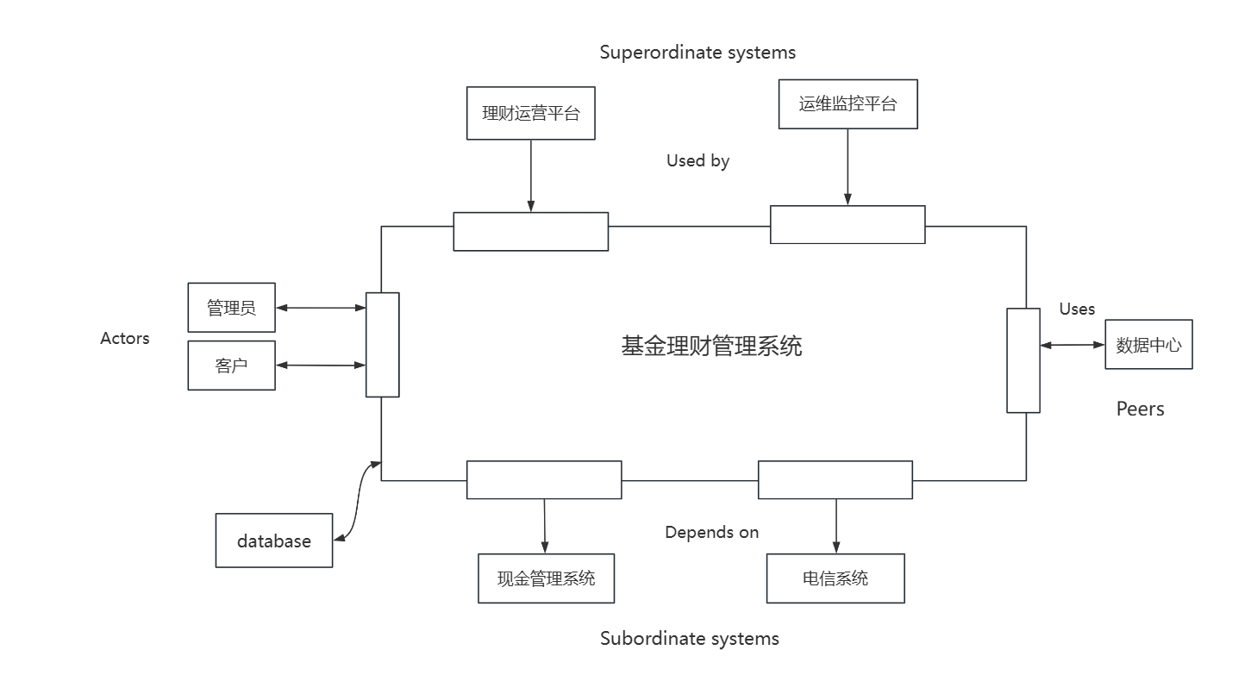

5.2. System Overall Process

In the WiseInvest System, users first log in through the front-end interface. Based on their identity:

If the user is a regular client, the system allows them to open an account and complete a risk assessment to determine their risk level. Clients can perform fund subscription or redemption operations. During subscription, clients select a fund product and enter the subscription amount to submit a request. During redemption, clients select held fund products and enter the redemption shares to submit a request.

If the user is an administrator, the system allows them to enter the clearing process. The clearing process includes daily initialization, receiving market data, confirming the previous trading day's subscription and redemption operations, updating holdings and account balances, closing the trading channel for the day, and exporting the day's transaction applications and confirmation data to the data center. Administrators are also responsible for product management, including adding, modifying, or deleting fund products in the system.

The system's activity diagram is as follows. 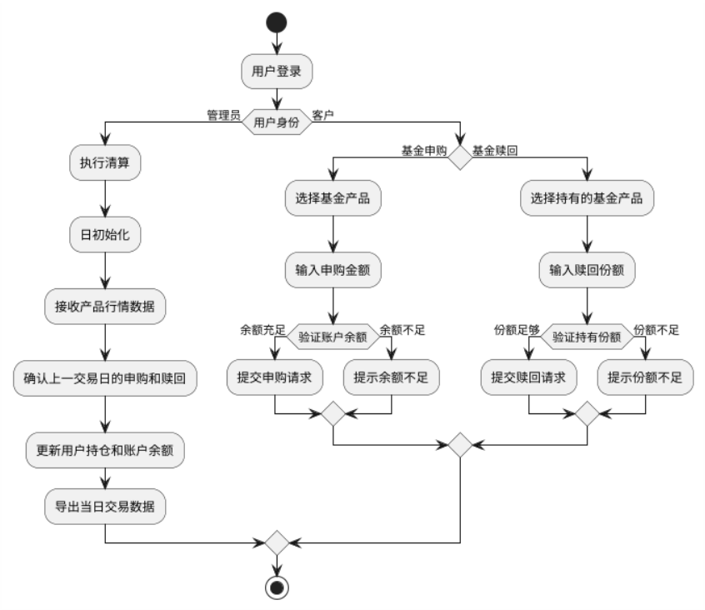

5.3. Requirements Analysis Modeling

5.3.1. Functional Modeling

## 5.3.1.1 Activity Diagrams

5.3.1.1.1 Product Management Subsystem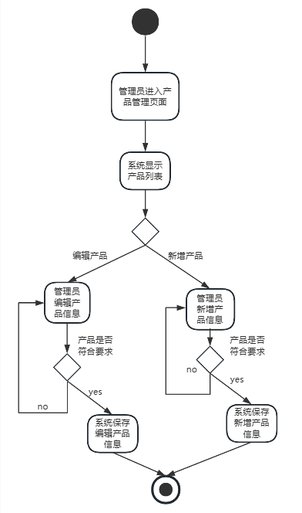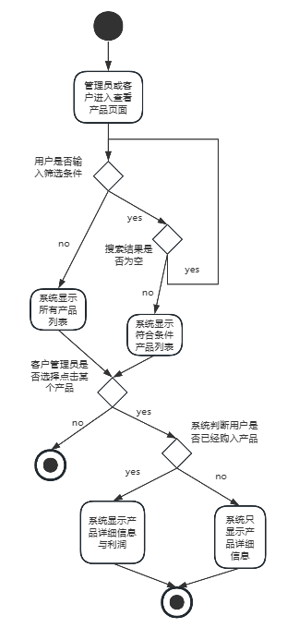

5.3.1.1.2 Account Management Subsystem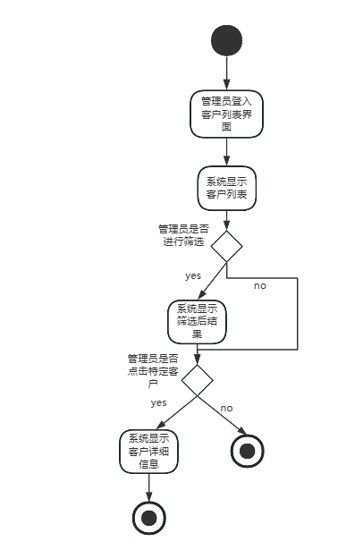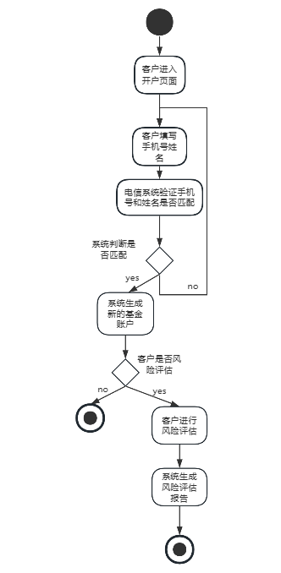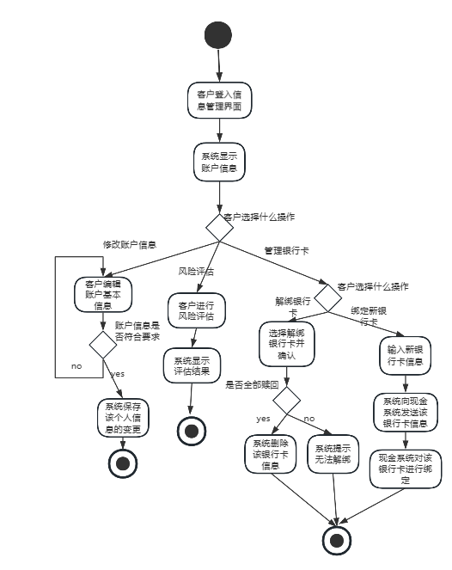

5.3.1.1.3 Subscription and Redemption Subsystem

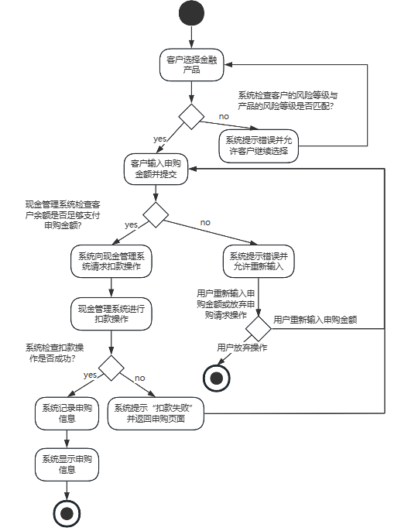

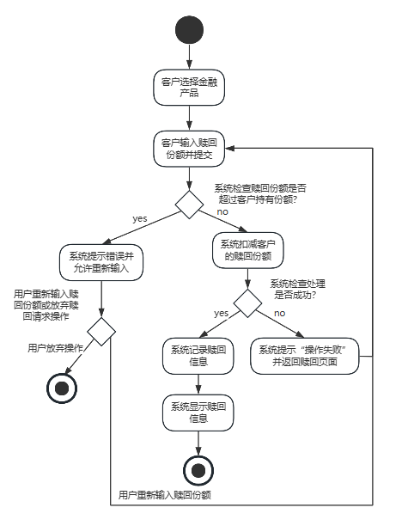

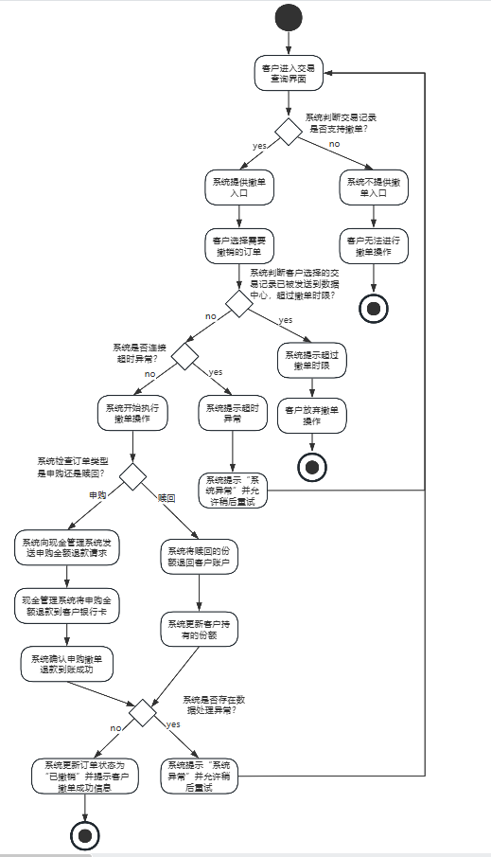

5.3.1.1.4 Settlement Subsystem

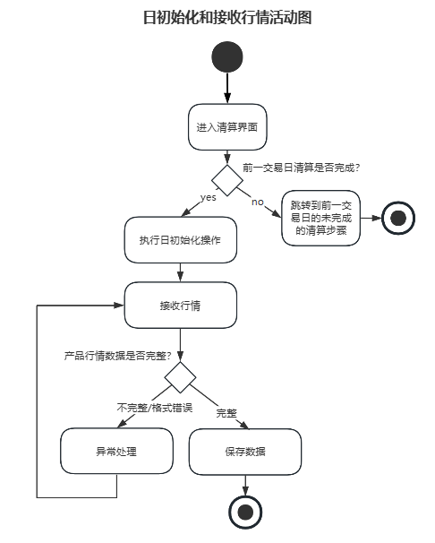

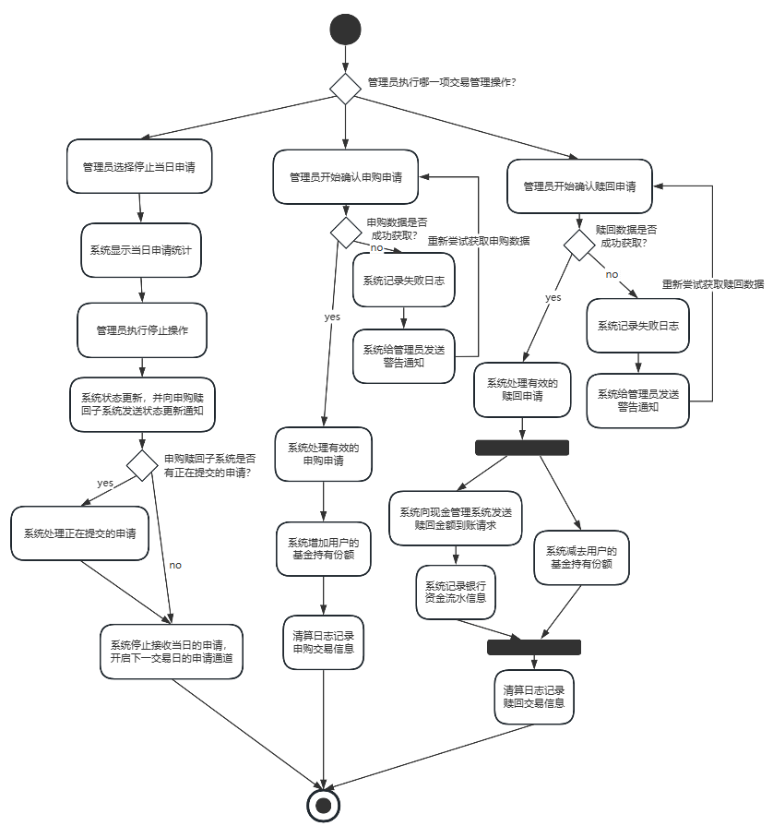

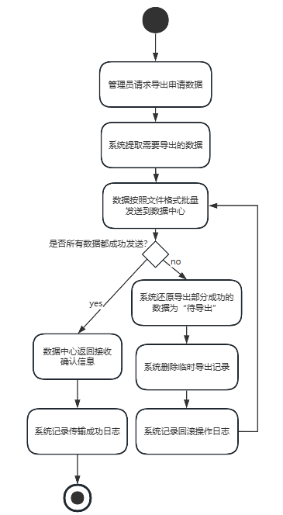

5.3.1.1.5 Business Inquiry Subsystem

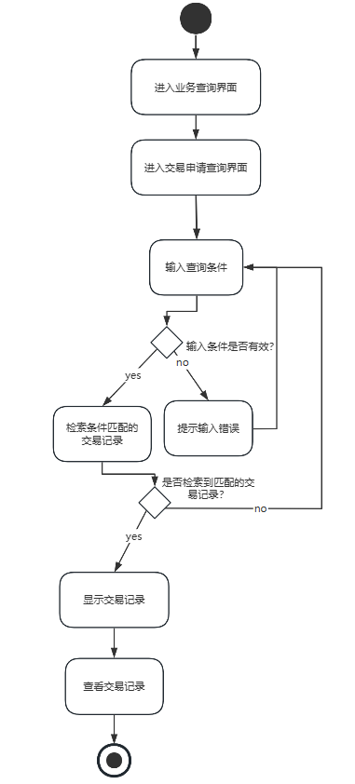

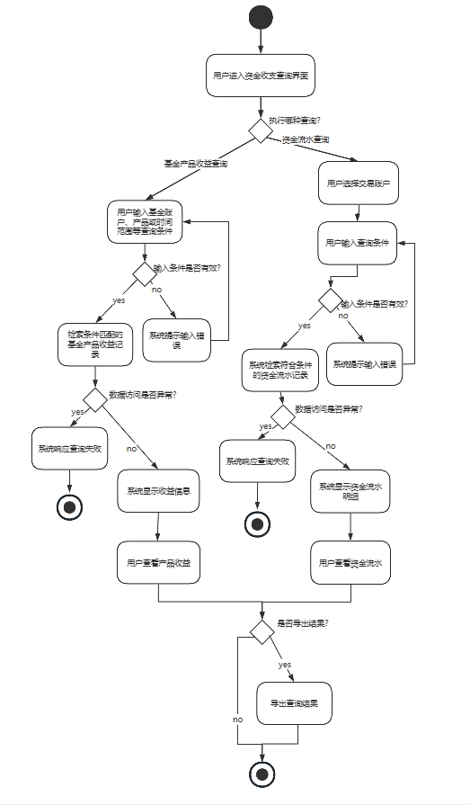

5.3.1.1.6 Login Subsystem

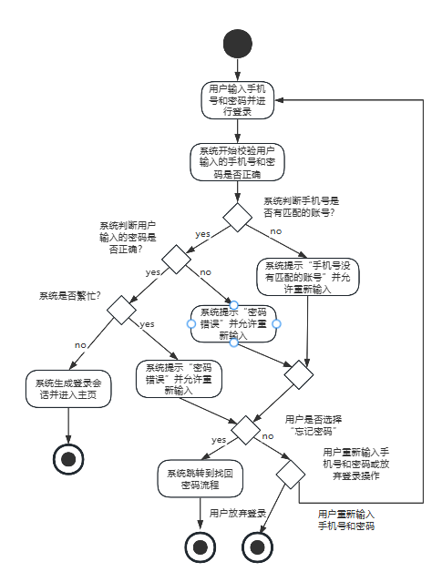

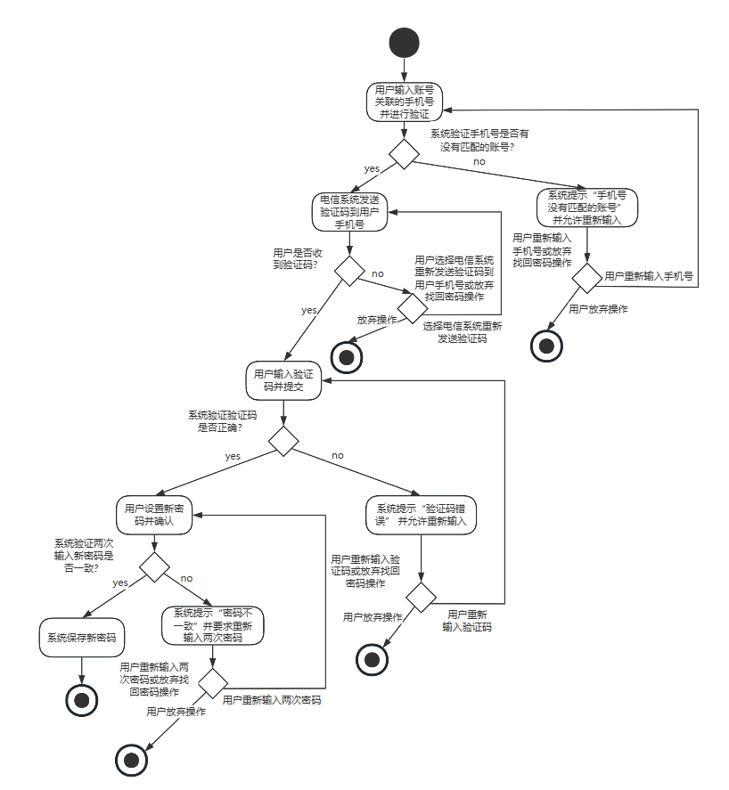

5.3.1.1.7 Intelligent Service Subsystem

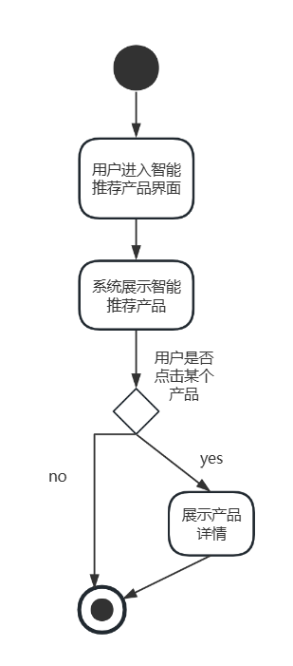 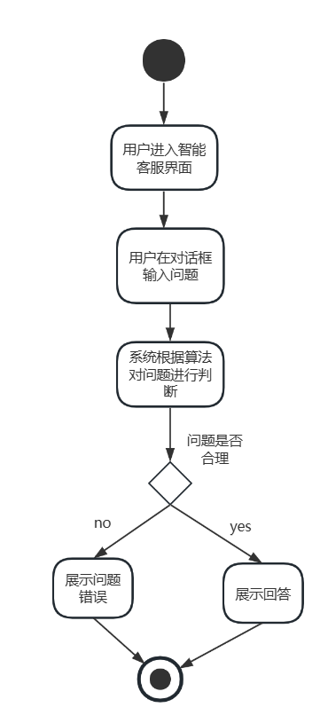

## 5.3.1.2  Swimlane Diagrams

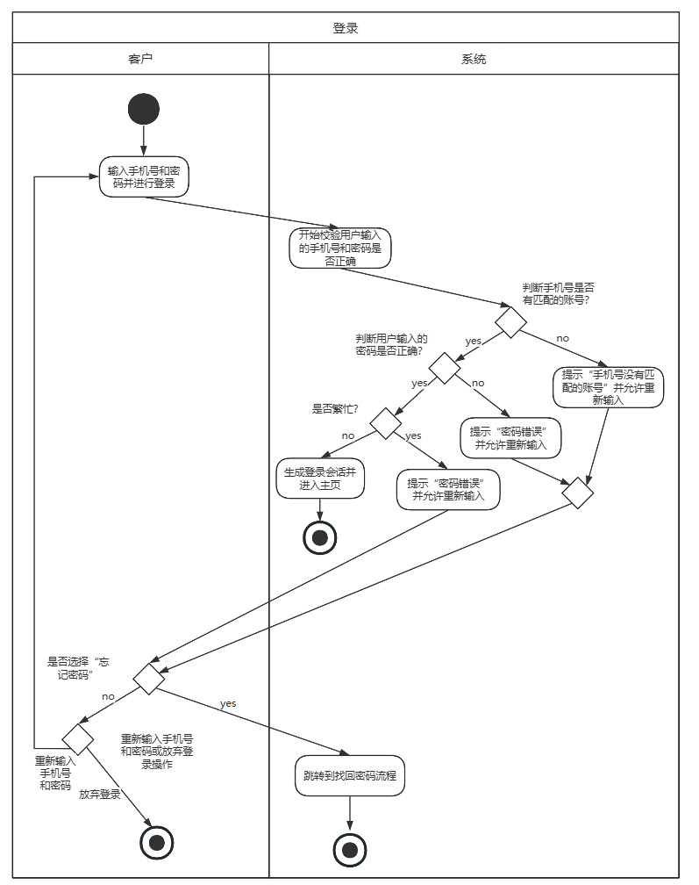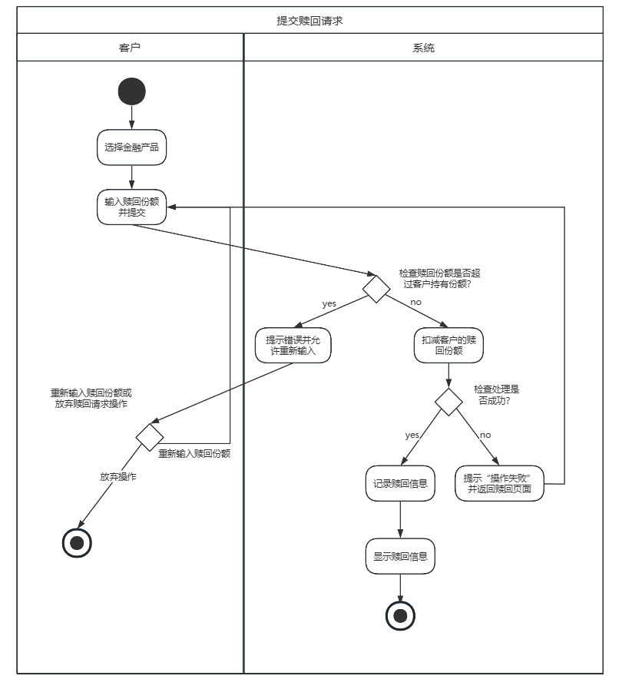

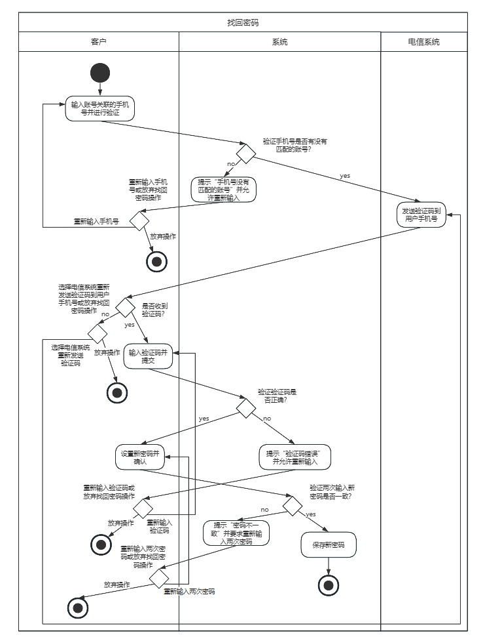

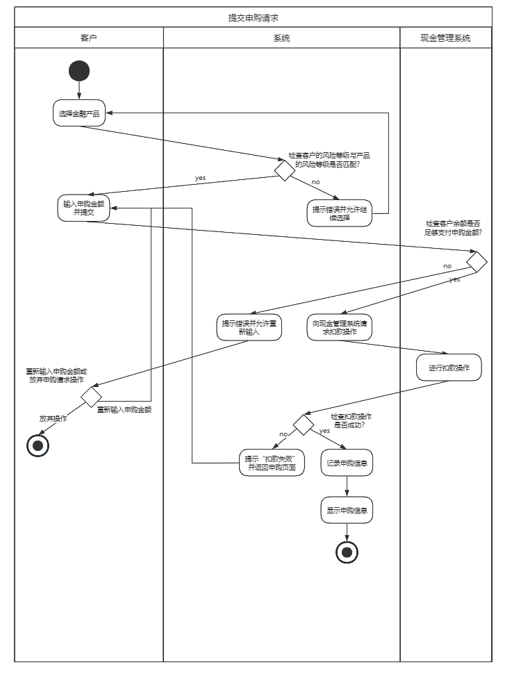

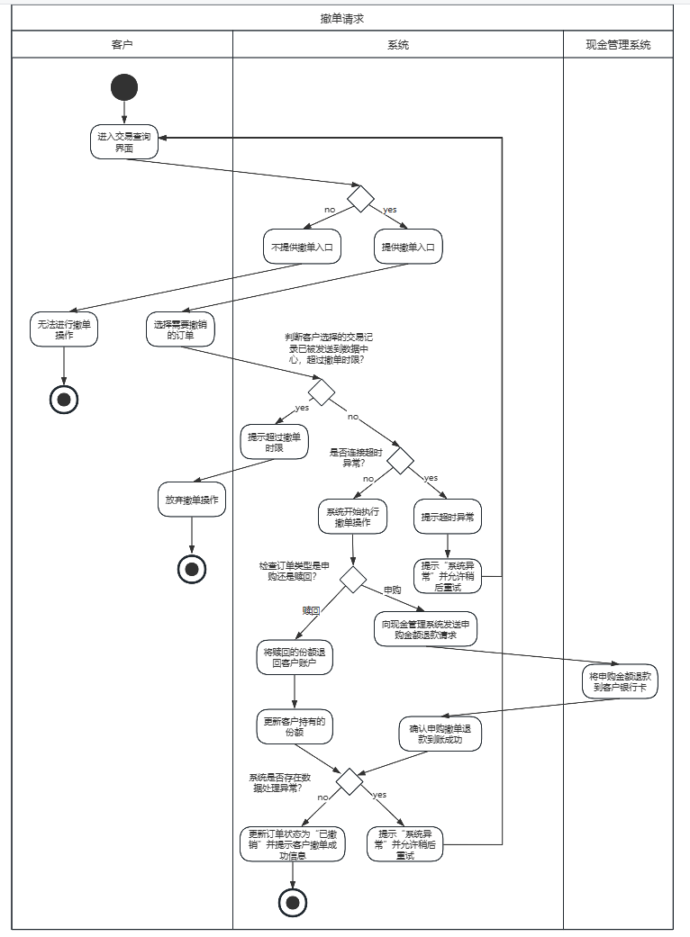

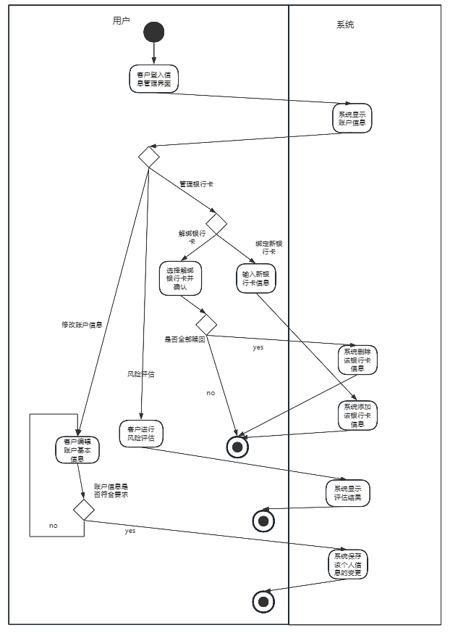

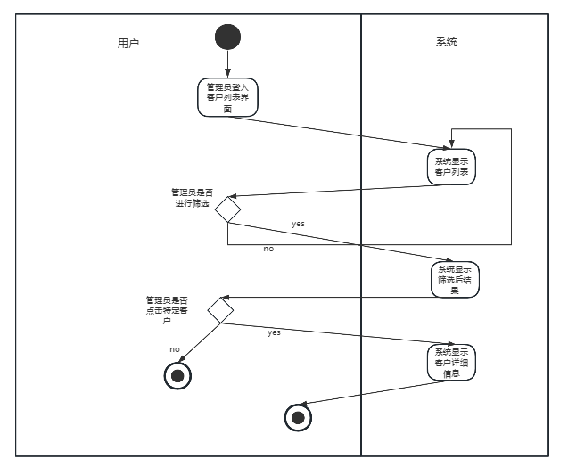

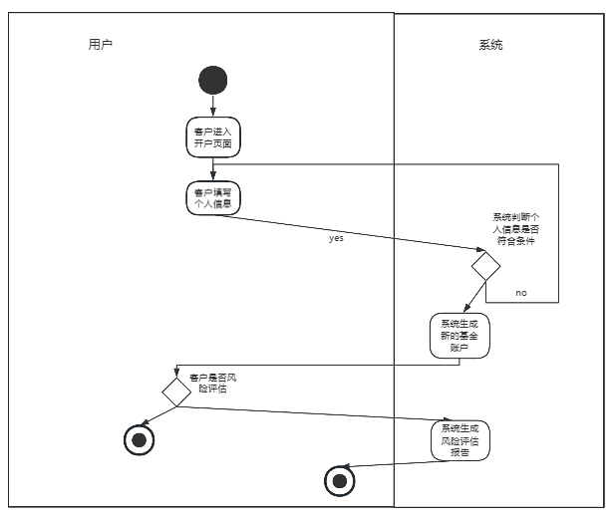

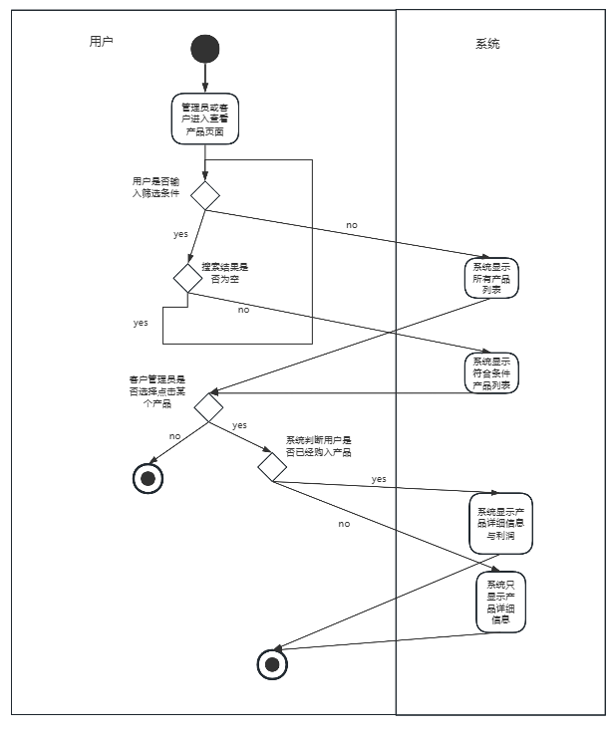

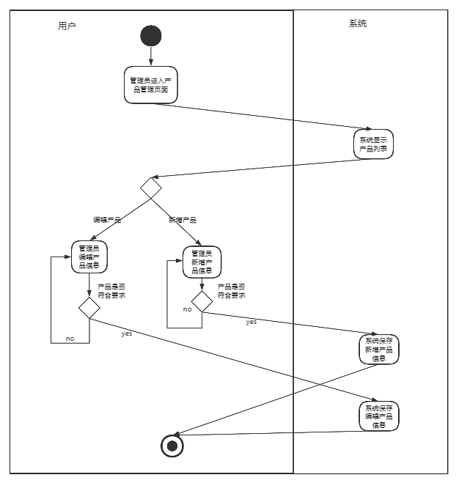

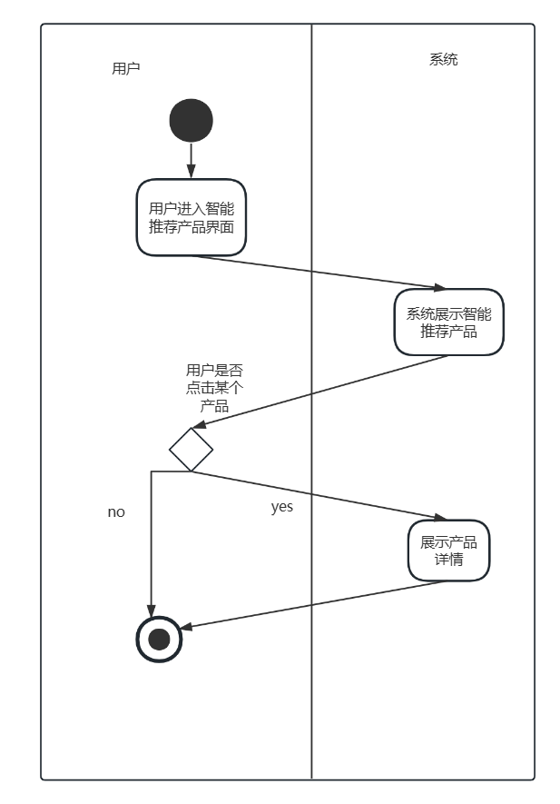

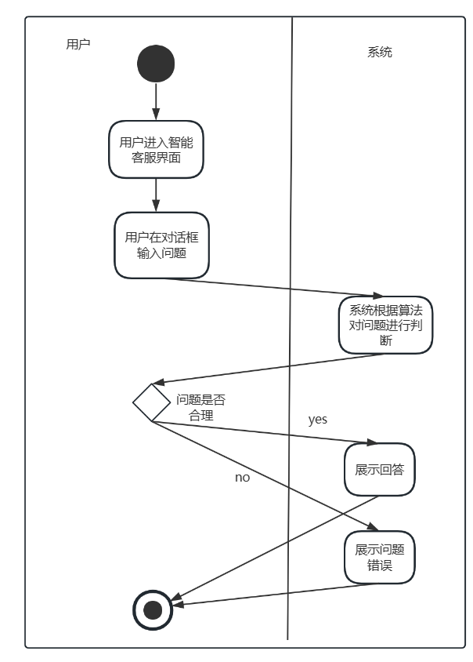

## 5.3.2. Data Modeling

Iteration1:

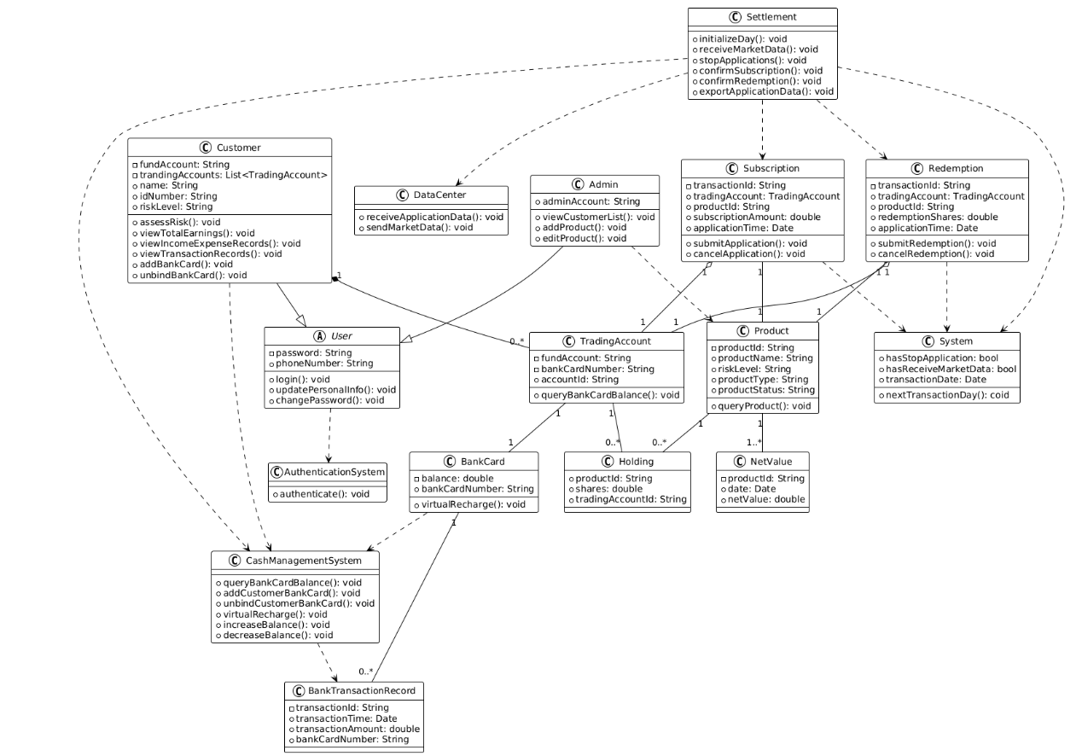

Iteration 2: Adjusted the relationship between classes, changing the association between the Customer class and Trading Account class to a "has-knowledge-of" relationship. Iteration 3: Removed the virtual top-up method from the BankCard class and delegated this functionality to the Cash Management System's API.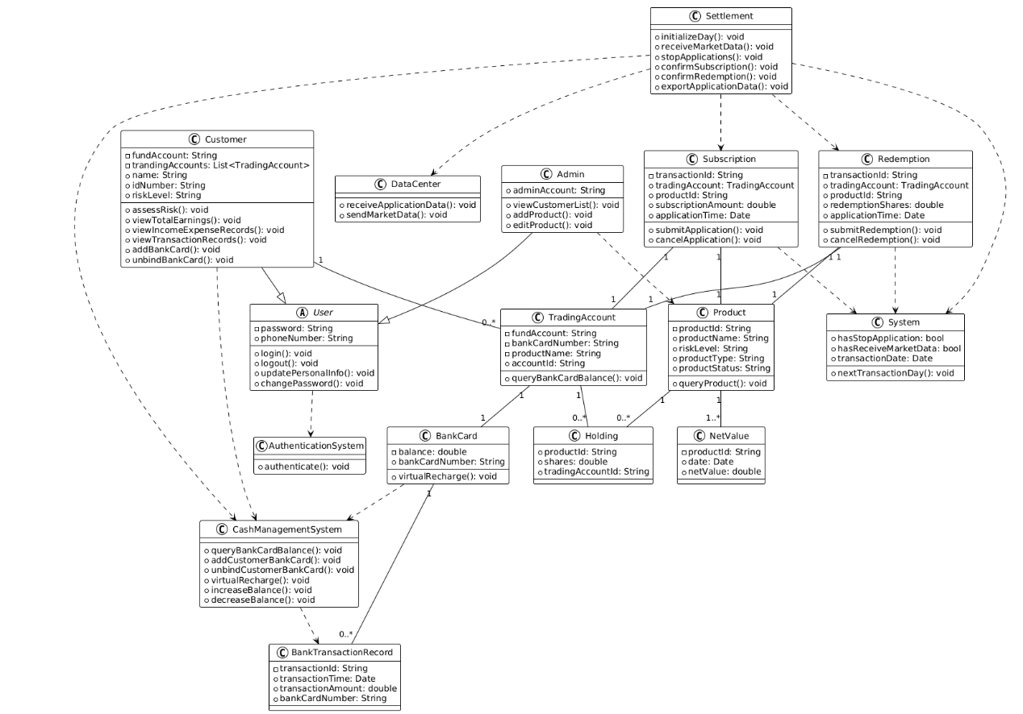

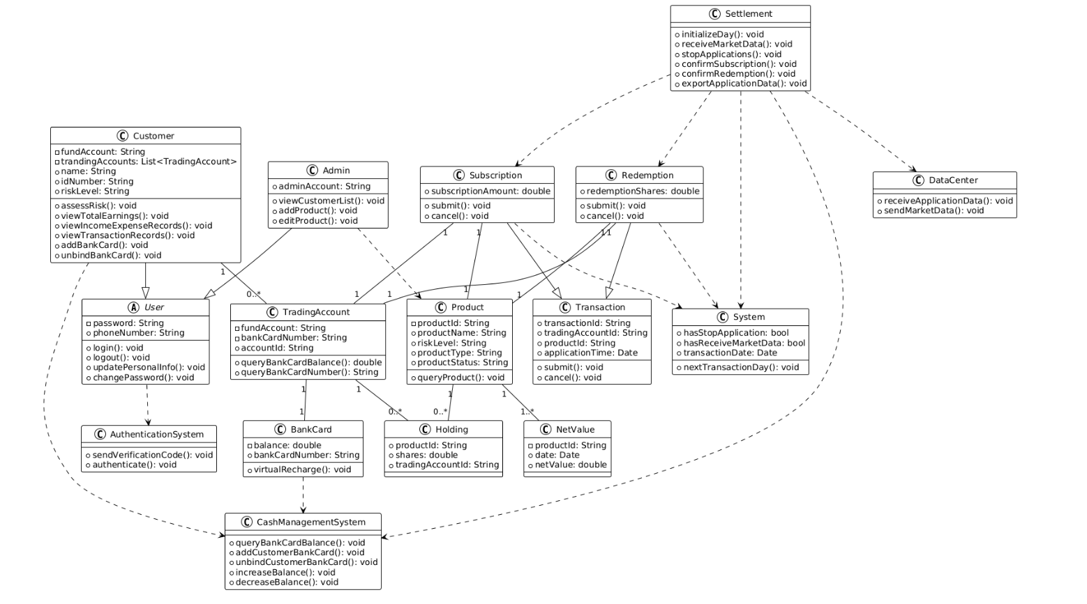

5.3.3. Behavioral Modeling

5.3.3.1 State Diagrams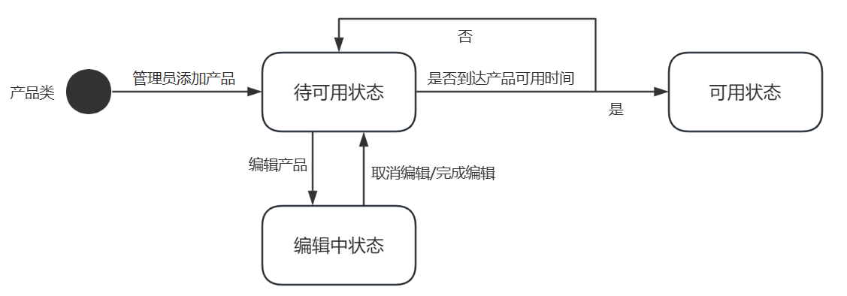

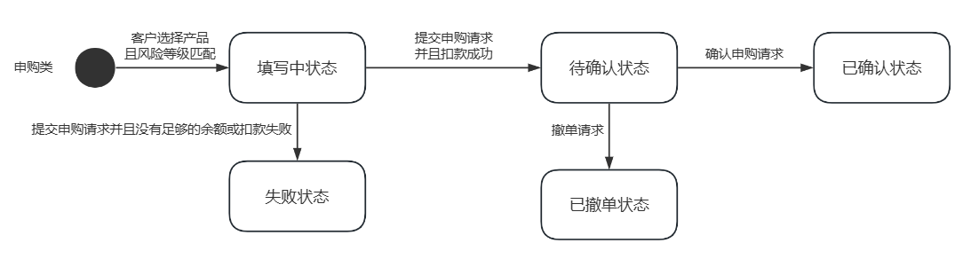

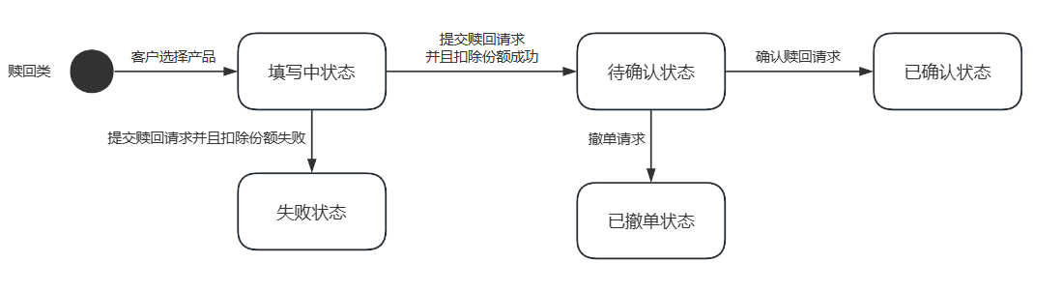

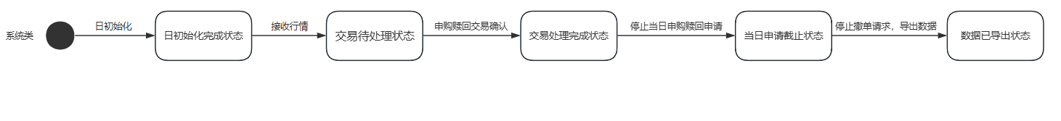

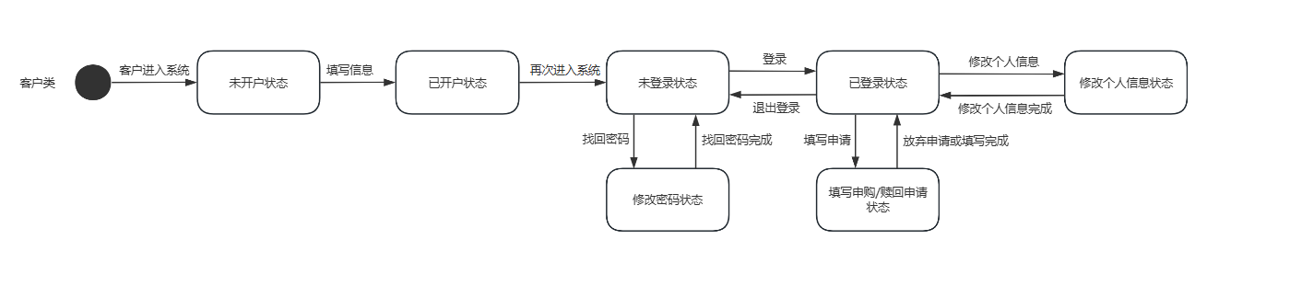

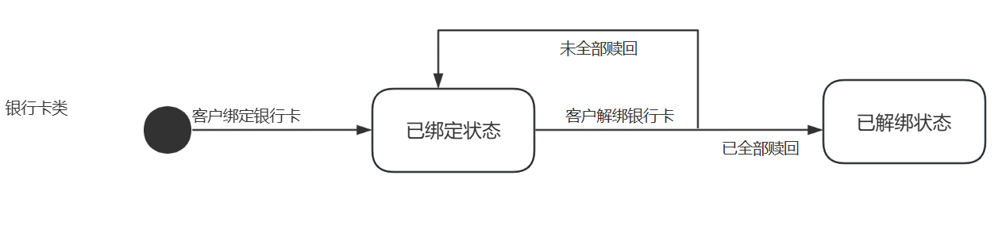

## 5.3.3.2 Sequence Diagrams

5.3.3.2.1 customers management Subsystem

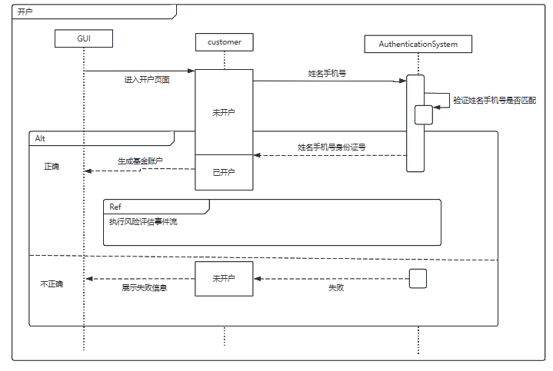

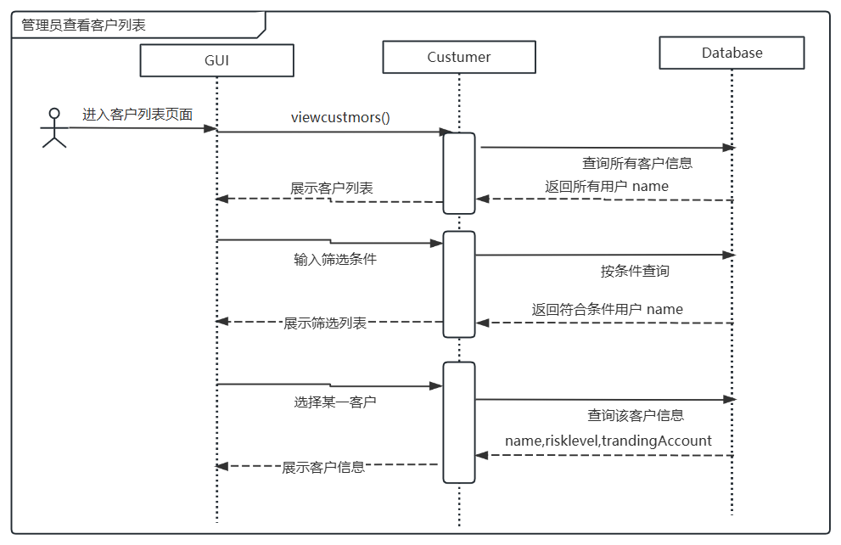

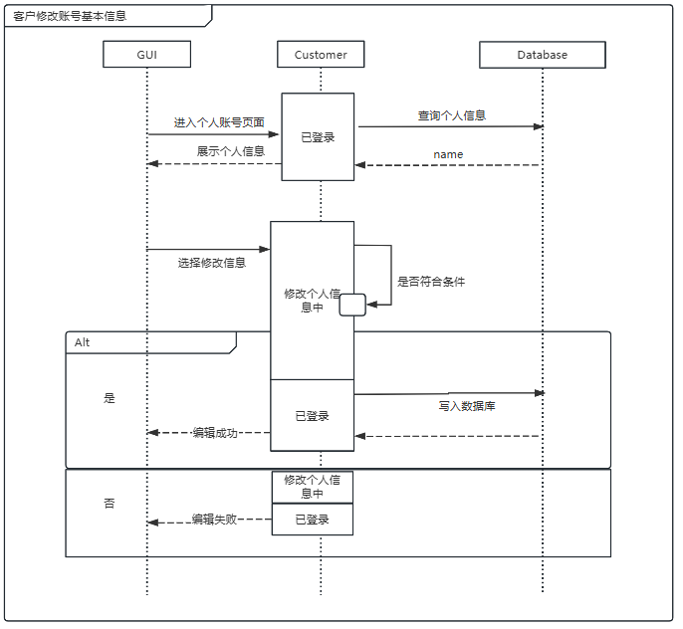

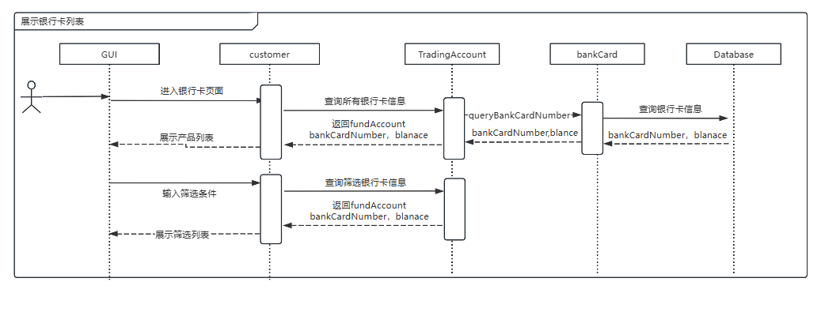

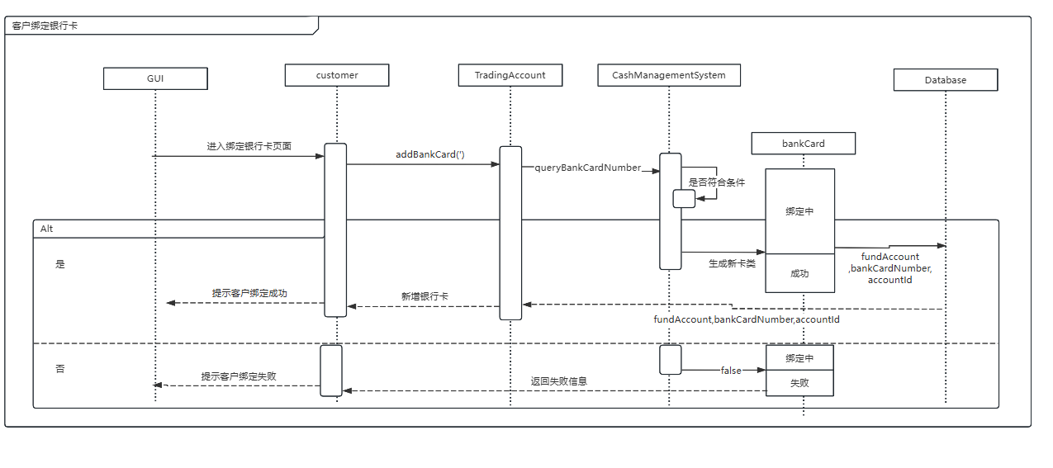

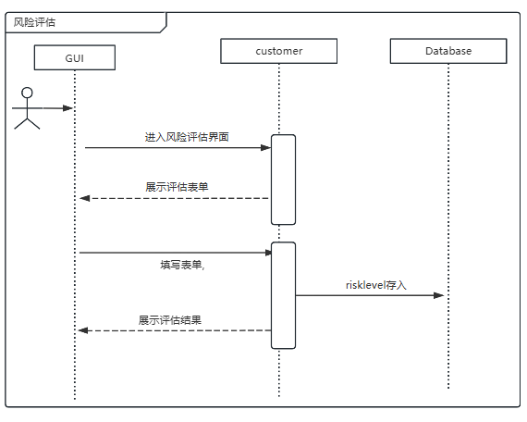

5.3.3.2.2 product management Subsystem

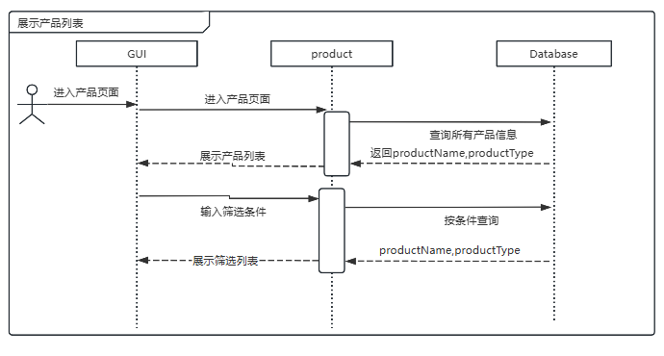

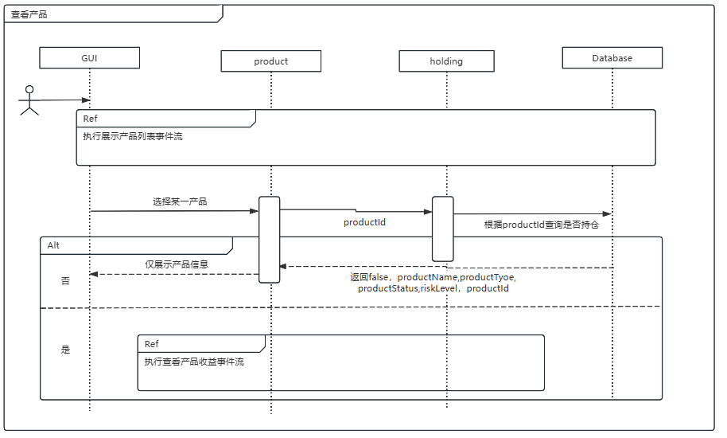

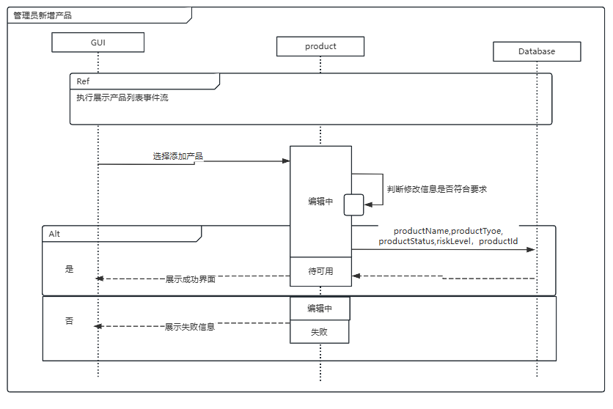

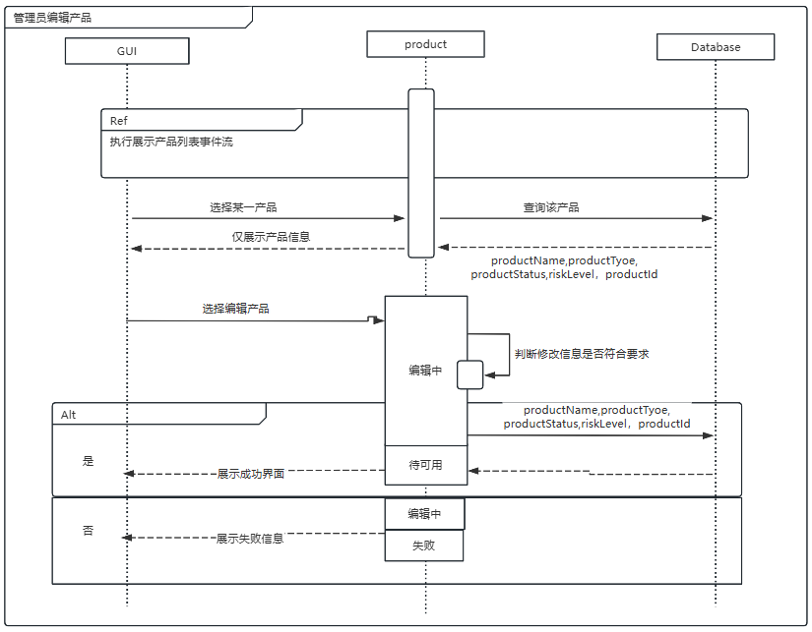

5.3.3.2.3 Subscription and Redemption Subsystem

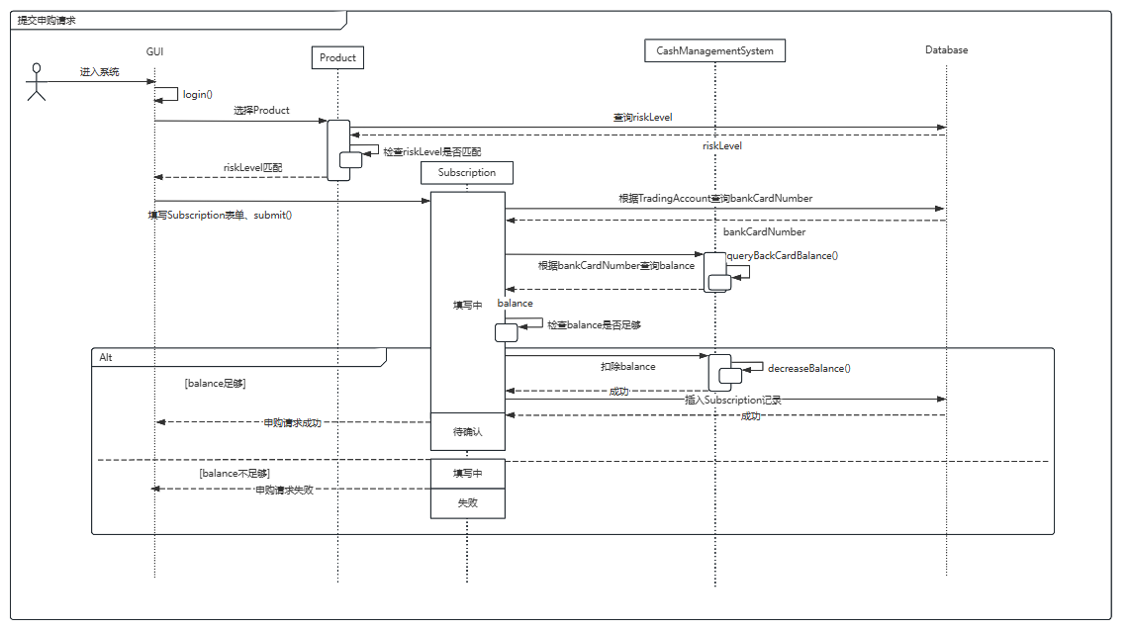

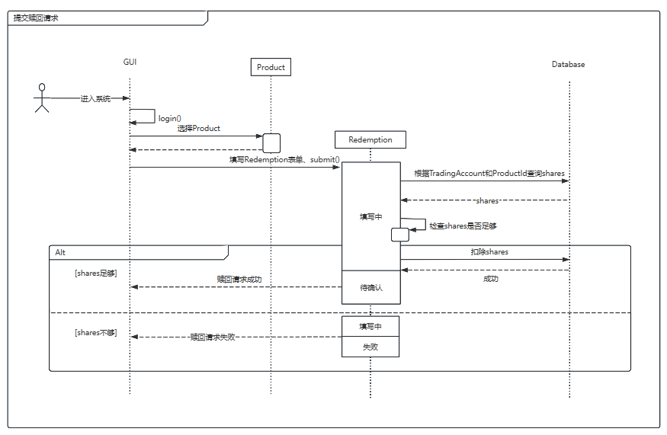

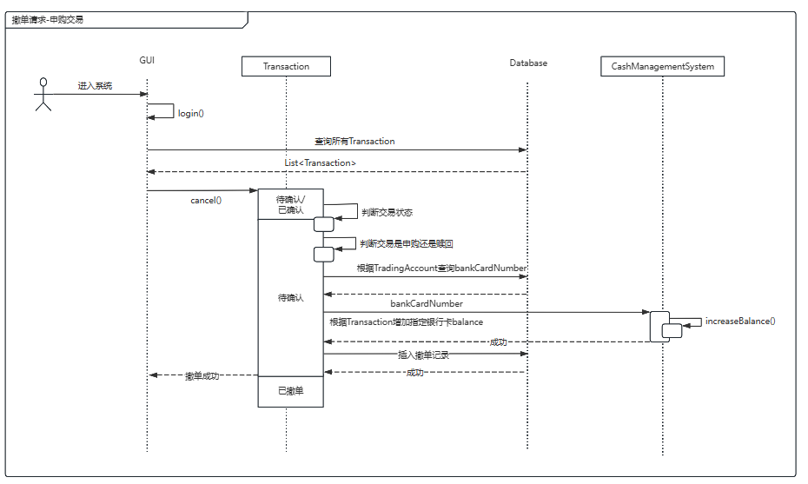

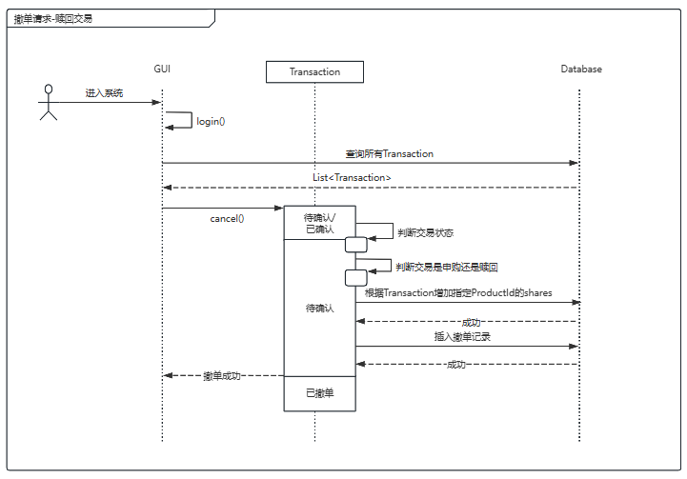

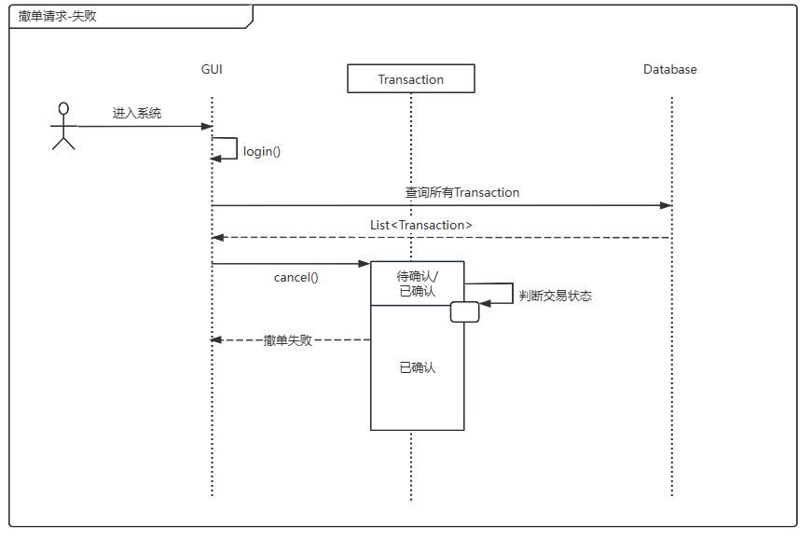

5.3.3.2.4 Settlement Subsystem

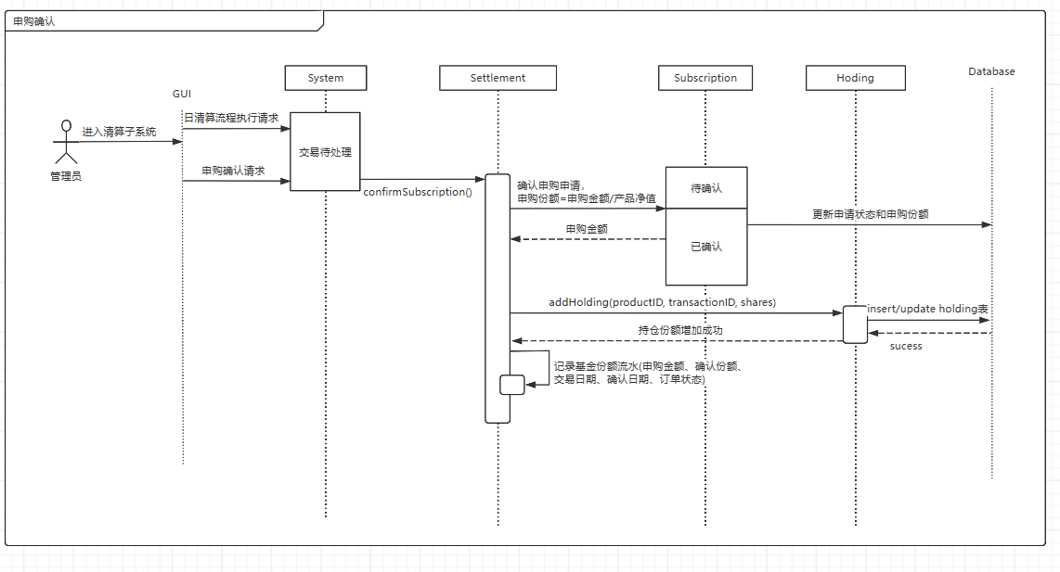

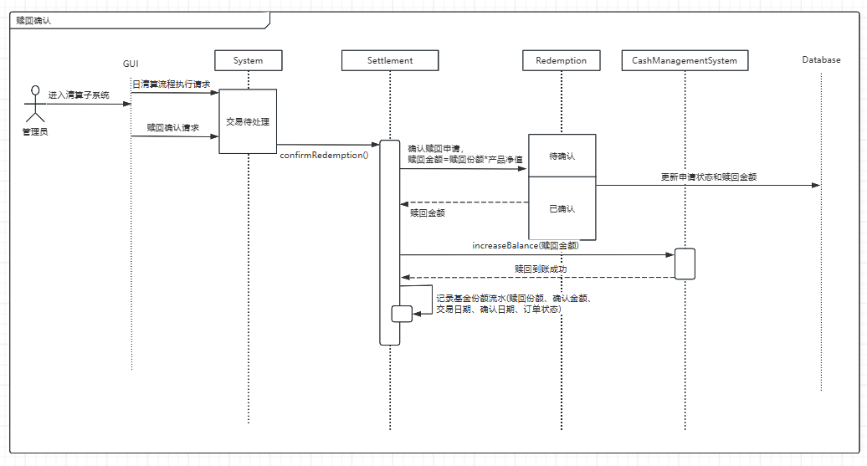

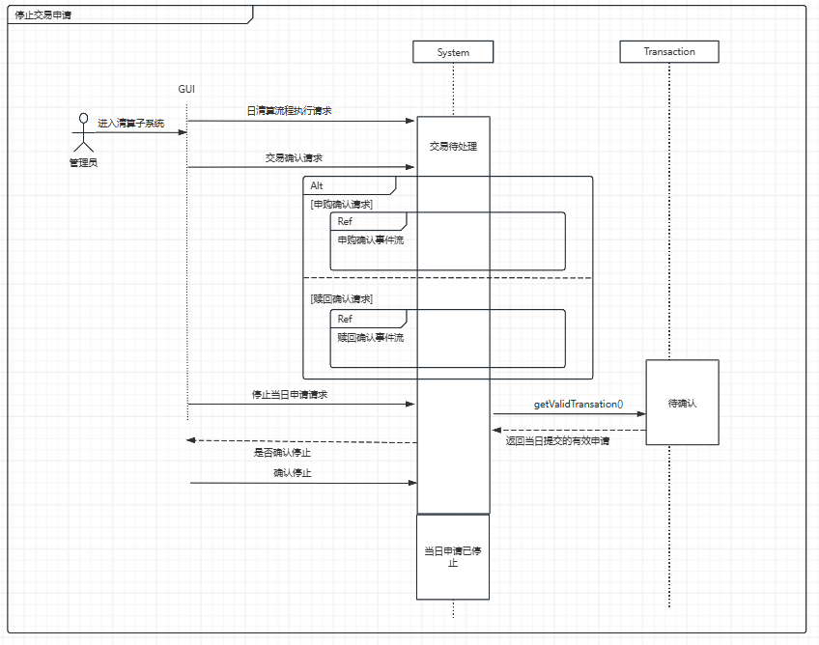

5.3.3.2.5 Login Subsystem

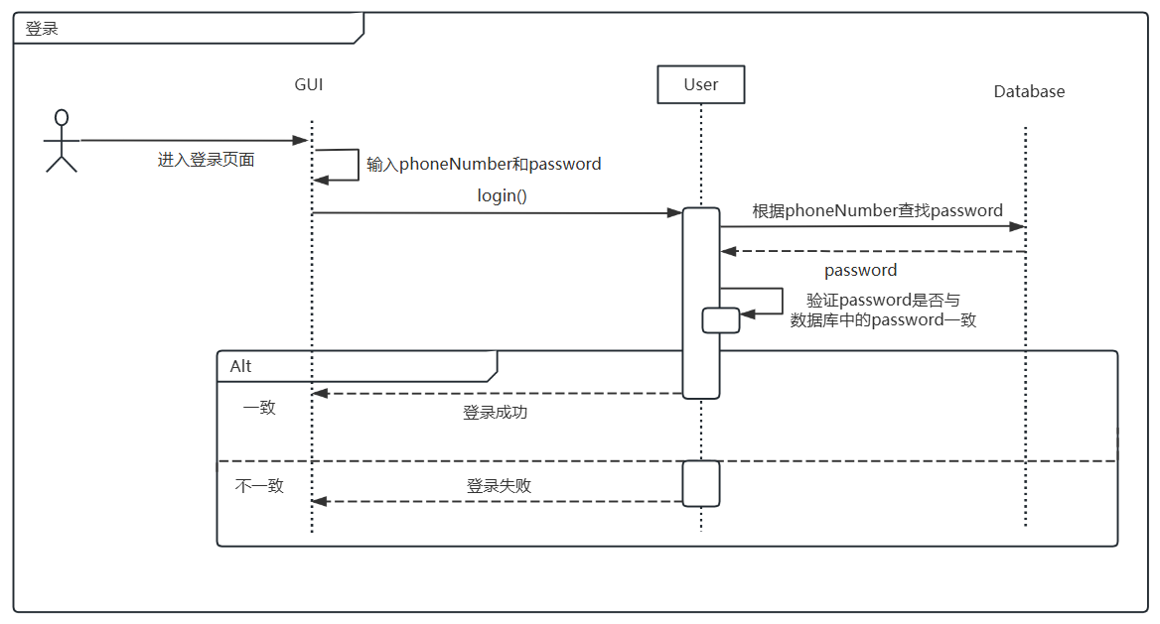

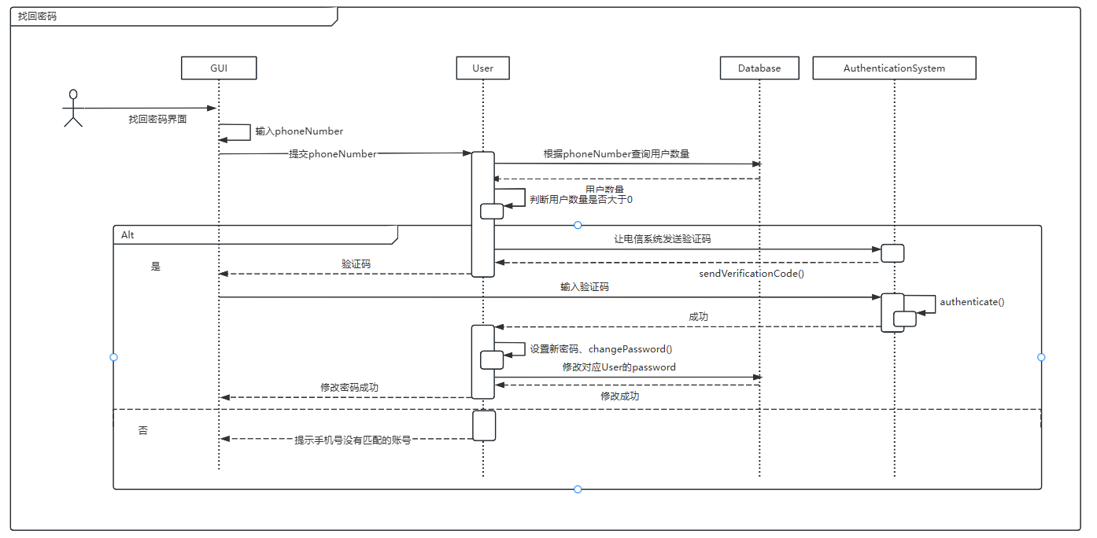

5.3.3.2.6 Intelligent Service Subsystem

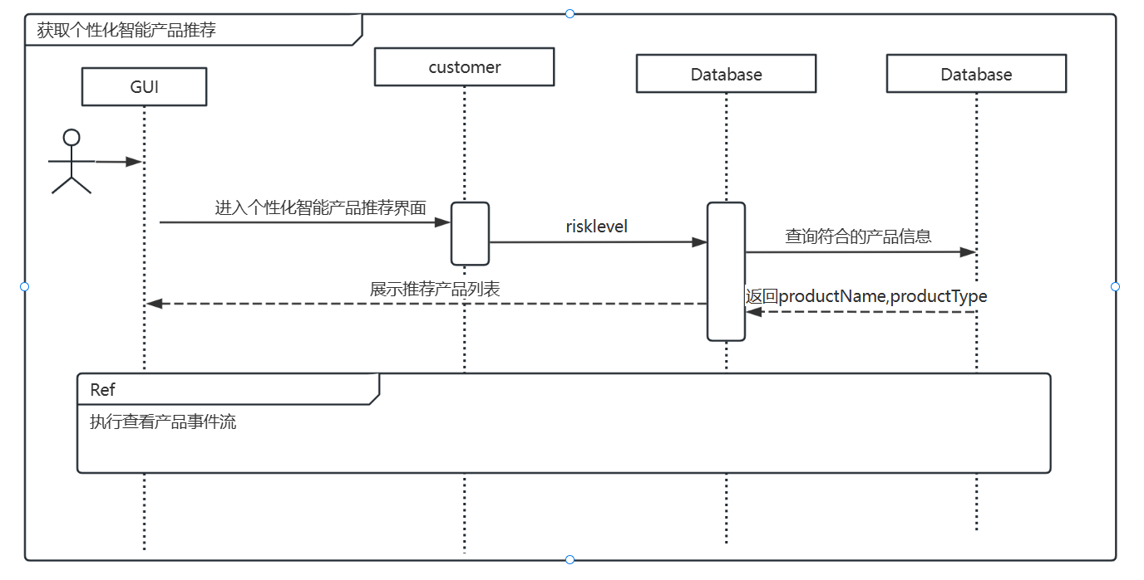

# 6 Non-Functional Requirements

## 6.1Performance Requirements

### 6.1.1 Precision

* Subscription and Redemption Amounts: The system must support precision up to two decimal places.
* Shares: The system must support precision up to four decimal places for transaction shares.
* Product Net Value: The system must support precision up to four decimal places for product net values.
* Data integrity and precision must be maintained during transmission.

### 6.1.2 Time Characteristics

Iteration1：

* Response Time: The system should respond within 1 second of user operation.
* Update Processing Time: Data updates and processing should complete within 2 seconds.
* Interface Update Transmission Time: Interface updates should complete within 1 second.

Iteration2：

* Batch Data Processing: The system should support efficient batch operations, ensuring processing time does not exceed 5 minutes for 1,000 transaction records.
* Concurrent Processing: The system should support at least 100 concurrent users for trading operations, with response times not exceeding 2 seconds.

### 6.1.3 Input/Output Requirements

* Input Data Types: Include user information, transaction requests, and product information in JSON format.
* Output Data Types: Include transaction confirmations, account information, and clearing results in JSON format.

## 6.2 Data Management Requirements

Iteration1：The system must manage hundreds of thousands of transaction records and user information, with an estimated annual data growth rate of 20%. The database must support efficient query and storage operations.

Iteration2：

* Data Storage: The system must manage hundreds of thousands of transaction records and user information, with an estimated annual data growth rate of 20%. The database must support efficient query and storage operations.
* Caching Mechanism: For frequently accessed data (e.g., product information, user information), the system should implement a caching mechanism to improve access speed.

## 6.3 Security and Confidentiality Requirements

Iteration1：

* Fault Handling: The system must have automatic fault detection and recovery capabilities to restore normal operation quickly after a fault.
* Data Security: The system must prevent unauthorized access, modification, or loss of confidential data, using encryption for data transmission and storage.

Iteration2：

* Error Handling and Logging:
  + Operation Logs: The system should log all critical operations, retaining logs for at least 6 months.
  + Retry Mechanism: For failed network requests, set a maximum of 3 retries with a 5-second interval.
  + Alert Mechanism: The system should notify administrators via email or SMS when system exceptions exceed 5 times or critical operations fail.

## 6.4 Flexibility Requirements

* Environment Adaptability: The front-end should support seamless operation on mainstream OS (Windows, macOS, Linux) and browsers (Chrome, Firefox, Safari, Edge).
* Responsive Design: The front-end interface should adapt to different screen sizes and resolutions, including desktops, tablets, and mobile devices.
* Interface Adaptability: The system should support API version management to ensure updates do not disrupt existing users or systems. It should quickly adapt to and integrate third-party service or system interface changes, reducing development and maintenance costs.
* Modular Design: The system should adopt a modular design for easy expansion and maintenance. Each module should be independently developed and tested to minimize impact on other modules.
* Scalability: The architecture should support horizontal and vertical scaling to accommodate user growth and business changes. Microservices architecture allows dynamic addition or reduction of service instances as needed.
* Performance Optimization: The design should include strategies like caching, asynchronous processing, and load balancing to improve response speed and processing capacity.

## 6.5 Other Specific Requirements

* Ease of Use: The interface should be simple and user-friendly.
* Maintainability: The code should be easy to maintain and extend, supporting quick fixes and updates.
* Reliability: The system should ensure high reliability and accuracy of transaction data.
* Exception Handling: The system should effectively handle exceptions, providing detailed error logs and messages.

# 7. Operating Environment Specifications

## 7.1 Hardware

* Recommended: Intel i5 or higher processor, at least 8GB RAM.
* Storage: At least 256GB SSD for faster read/write speeds, supporting NTFS or ext4 formats.
* Input Devices: Standard keyboard and mouse.
* Output Devices: At least one 1080p display.
* Data Communication: Supports Ethernet or Wi-Fi, with Gigabit Ethernet recommended.
* Special Hardware: No special requirements; standard PC configuration suffices.

## 7.2 Supporting Software

* Network and Hardware Platform: Supports mainstream PC hardware, compatible with Windows, macOS, and Linux.
* OS Platform: Windows 10+, macOS 10.15+, Ubuntu 18.04+.
* Database: MySQL 5.7+.
* Development and Testing Tools:
  + Front-end: Node.js 14.x+.
  + Back-end: Java 11+.
  + Testing: IntelliJ IDEA for JUnit, Postman for integration testing, Apache JMeter for performance testing under high concurrency.

## 7.3 Interfaces

* The system uses RESTful APIs for data interaction with other services, supporting JSON format and HTTP/HTTPS protocols for secure data transmission.

## 7.4 Controls

* The system is operated and controlled via a web interface accessed through browsers.
* User inputs are passed to back-end services via the front-end, and results are returned through APIs.